Operation Manual
HM-A50 Trolley Cable Fault Locator

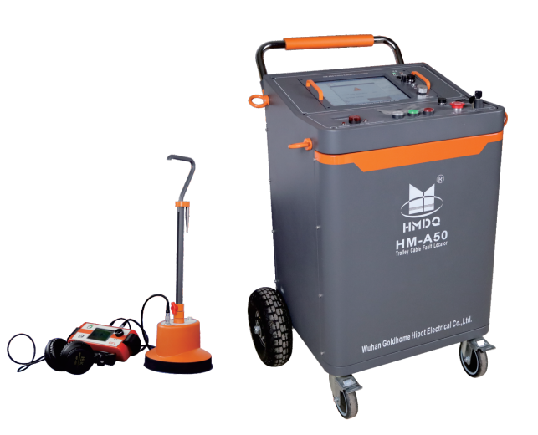

WUHAN GOLDHOME HIPOT ELECTRICAL CO.,LTD
Cel.：+86-13720185294 Tel：+86-027-84620387
Email：goldhome02@cablehipot.com Web.: www.hvcablehipot.com
Add.: No.A25-1, Huading Mould Industrial Park, Hannan, Wuhan, Hubei, China

CONTENTS
Section I HM-A50 cart cable fault tester each function and parameter introduction 1
I.HM-A50 Trolley Cable Fault Tester Advantages and Features 1
II. Functional features of each unit of the whole machine 2
III.Technical parameters of each unit of the whole machine 4
IV. Introduction to the front and rear test panels of the whole machine 6

Section II Testing Procedure for Power Cable Faults 10

Section III Introduction to Cable Test System Software 11
I. Cable test system mainframe 11
II. Introduction to the test system control interface 11
III. Operational steps 13

Section IV Introduction to cable fault test methods 20
I. Cable fault test principle 20
II. Low-voltage pulse test mode 20
III. Multiple Pulse Method Test Method 25
IV. Impulse Flash Flow Test Methods 29

Section V High Frequency High Voltage Power Supply Unit Instructions for Use 31
I. Operation Panel 33
II. Touch Display 33
III. Introduction to use 34
IV. Precautions 37

Section VI HM-C10 Intelligent Fixed-point Meter Introduction 37
I. Overview of the Fixed Point Instrument 37
II. Field Installation and Operation of Fixed-point Instruments 40
III. Getting Started with the Fixed-Point Meter 44

Attention:
Welcome to choose our company's instruments and equipment. It is recommended that they be kept and used by designated persons. Please charge them once if they are not used for half a year. Please push and pull gently when moving. In case of instrument failure, the main box must not be opened at will. Please contact the manufacturer.

Section I HM-A50 Trolley Cable Fault Tester Introduction
HM-A50 trolley cable fault tester is a trolley cable fault test system that our company has been committed to in the field of power cable fault testing for a long time. In order to cater to the rapid development of the power industry, combined with various experiences and intensive research, it highly integrates traditional, independent cable fault distance measurement, integrated high-frequency high-voltage power supply, multiple pulse generator, automatic discharge and other independent units into one. The distance measurement unit of this system is cleverly embedded, the high-voltage design is compact and safe, and the built-in unit has strong anti-interference. The system is used for rough testing of various fault distances of power cables and precise fault location. The test software can automatically identify the card position and read the fault distance, which truly makes the cable fault test light, simple, efficient, and safe, and provides convenience for the rapid testing of power cable faults.

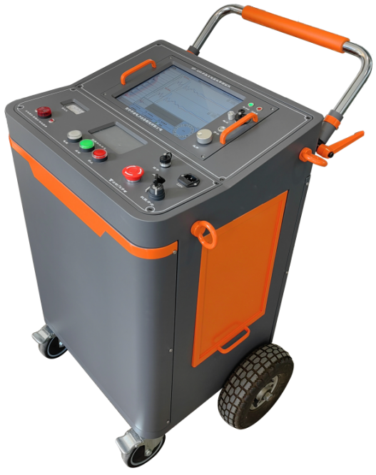
HM-A50 trolley cable fault tester advantages and features
- The system adopts embedded highly integrated integration design, strong anti-interference, easy and flexible to move.
- It is suitable for testing all kinds of main insulation faults of power cables of different voltage levels.
- The fault test unit adopts an embedded host and Linux operating system.
- The high-frequency and high-voltage power supply unit touch screen control system embodies human-computer interaction, convenient operation, simple and intuitive display.
- The system is equipped with a 25m test line, which is convenient for cable fault testing at long and short distances and in complex environments.
- The whole machine is designed according to European standards and has an authority key for professionals
- The whole machine has a ground loop monitoring protection system to protect equipment and personal safety in real time.
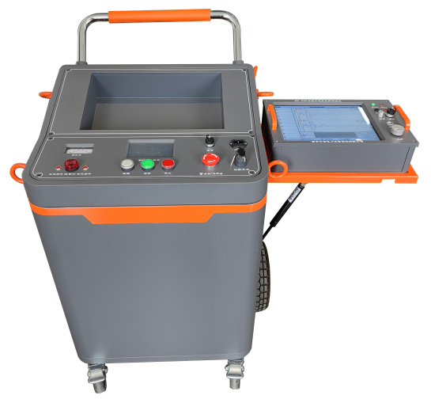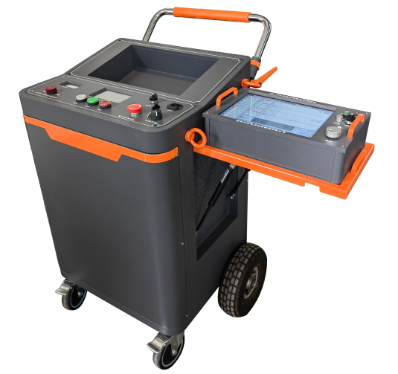

- Functional features of each unit of the whole machine
- Fault test unit (embedded) advantageous characteristics:
◆ It adopts 12.1in large screen, knob mouse control, high-brightness LCD display, suitable for outdoor use in the sun, lithium power supply, convenient for on-site testing. Engineering plastic chassis, shockproof and moisture-proof, with strong stability.
◆ The flash tester is equipped with a WIFI module and a SIM interface, which can realize the wireless remote transmission of measurement data and technical support of mobile terminals. It adopts integrated communication technology, and the acquisition signal is stable. The host can automatically select eight sampling frequencies from a minimum of 3.125MHz to a maximum of 400MHz, and has an adaptive pulse width to meet the test requirements of cables of different lengths.
◆ The software realizes automatic switching among low voltage pulse method, flash current method and multiple pulse method. The wiring is simple and the test is intuitive. It can automatically identify and search the inflection point of the test waveform, automatically locate the inflection point of the waveform fault, and automatically read and display the fault distance.
◆ Waveforms are displayed in three areas on the same screen. Ten measured waveforms are randomly displayed on the same screen for selection. Both automatic and manual processing modes of waveform position verification are realized. It has the function of test waveform data storage, playback and analysis.
◆ Unique multiple pulse generator design, one discharge can produce ten low-voltage short-circuit pulse waveforms, automatically select the standard waveform, greatly reducing the interference of large oscillations
◆ The professional Cable Quick Test APP supports remote assistance to users in waveform analysis, case sharing, teaching and training, simulated exams, etc. anytime and anywhere.

- High-frequency high-voltage power supply unit advantageous features:
- Touch screen human-computer interaction, easy to set up and operate, instrument status display is intuitive and convenient.
- It has voltage regulation, automatic voltage stabilization and automatic protection functions.
- The output high voltage has the function of single pulse and continuous pulse, which can be used with fault tester and fixing point meter to find the fault point respectively.
- The output high voltage has a DC output and can work with an external ball gap for diversified applications.
- Software controls vacuum impact ignition discharge, adaptive discharge and pulse cycle.
- It has emergency stop button and automatic discharge function, which can automatically reduce voltage and discharge in case of emergency stop or shutdown, which is safe and reliable.
- Continuous working time of not less than 4 hours to meet the working time of cable fault testing.

- Ultra-quiet intelligent fixed-point instrument advantageous features:
◆Precise Spotting Instrument adopts the dual-selective technology of squelch filter and BNR intelligent background noise reduction, which is convenient for quick spotting in different environments.
◆Acoustic and magnetic synchronization technology can directly digital synchronization display test point and fault point distance change, while detecting the cable path towards and walk through the fault point and prompt return.
◆ Precision spotting instrument can support cell phone APP, connecting cell phone and headset through Bluetooth Bluetooth, realizing one probe two people at the same time fast spotting.
◆Molded and designed with a liftable and retractable handle for use with the human body and a special self-falling ground probe sensor with sensing probes for soft pavement, hardened pavement, and lawn.

- Technical parameters of each unit of the whole machine
◆ External dimension: 530(L)*430(W)*960(H)mm
◆ Weight:≤ 90Kg
◆ Input power: AC220V±10%, 50Hz
◆ Charging adapter: DC16.8V
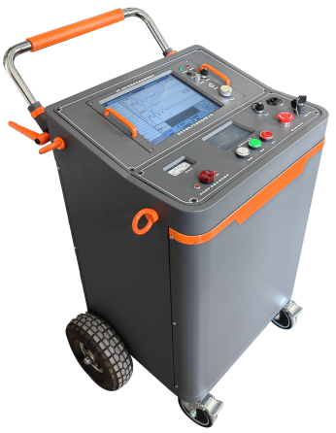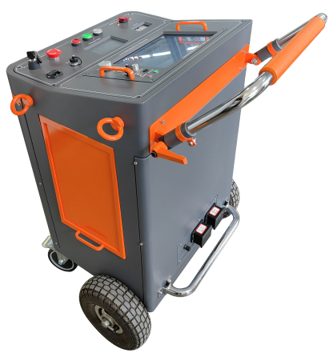
HM-A50 Trolley Cable Fault Tester Overall Diagram HM-A50 Trolley Cable Fault Tester Rear View

1. Trolley Cable Fault Tester host unit
Technical parameters:
- It can test all kinds of main insulation faults of power cables of different voltage levels, different cross-sections, different media and various materials, including: open circuit, short circuit, low resistance, high resistance leakage, high resistance flashover faults.
- Display: 12.1-inch industrial-grade LCD (Linux operating system).
- Storage space: 32G electronic disk.
- Language: Chinese, English and Russian language switching
- Test methods: low-pressure pulse method, high-pressure flash method, multiple pulse method.
- Operation mode: touch screen plus photoelectric knob dual operation (touch screen function optional)
- Pulse width/pulse amplitude (100ns~10μs, 120V)
- Gain adjustment (-20...+40dB)
- Output Impedance Matching (120 Ohms)
- Flash tester with WIFI module and SIM interface can realize the remote transmission of test data
- Testing distance: 5m-100km.
- Minimum test distance (blind spot): 5 meters.
- Precise pointing error: ±0.2m.
- Testing Error: System error is less than ±1%.
- Multiple pulse generator: Impulse voltage ≤ 40kV.
- Resolution: v/(2f) meters. (v: propagation velocity m/μs; f: sampling frequency MHz)
- Sampling frequency: 400MHz, 200MHz, 100MHz, 50MHz, 25MHz, 12.5MHz, 6.25MHz, 3.125MHz.
- Power supply and power consumption: AC220V±10%, not more than 15W; DC12V (7AH) not more than 20W.
- Standby time: can be used continuously for about 6 hours.

2. High-frequency high-voltage power supply unit:
This unit is mainly used for 220kV and the following power cable fault test when the high resistance fault waveform sampling impact discharge and fault point precise fixed point when doing impact discharge use.
Output mode: pulse output, DC output
- Output voltage: negative voltage, ≤32kV
◆ Operating current: ≤10A
- Operating mode: single pulse, continuous pulse, DC output
◆ Built-in capacitance: 4uF/32kV
- Discharge energy: ≤2048J
◆ Pulse period: 4s～9s adaptive
- Automatic discharge: automatic discharge after stopping the machine
◆ Working power supply: 220V±10% of working frequency.
- Display screen: 800 × 480 resolution touch screen display

- Super-silent Intelligent Fixed-point Instrument Part
- Sensor dynamic range: sound channel>104dB, magnetic field channel>110 dB sensor frequency range: 100 Hz---1500 Hz
- Impact discharge sound amplification >90dB, shock discharge volume limit 84dB(A) can be turned on or off
- Wave setting: no filtering 100 Hz--1500 Hz
- Low-pass filtering: 100 Hz---400 Hz Band-pass filtering: 150 Hz---600 Hz High-pass filtering: 200 Hz---1500 Hz
- LCD monitor: high brightness true color screen, pixels 320 x 240 Adaptable to outdoor.
- On-site continuous operating time: Alkaline replaceable battery cells for easy on-site use

IV. Front and rear test panels of the whole machine Introduction
(a) The schematic diagram of the tester panel is shown below, please pay attention to select the corresponding output port and switch according to the test requirements.
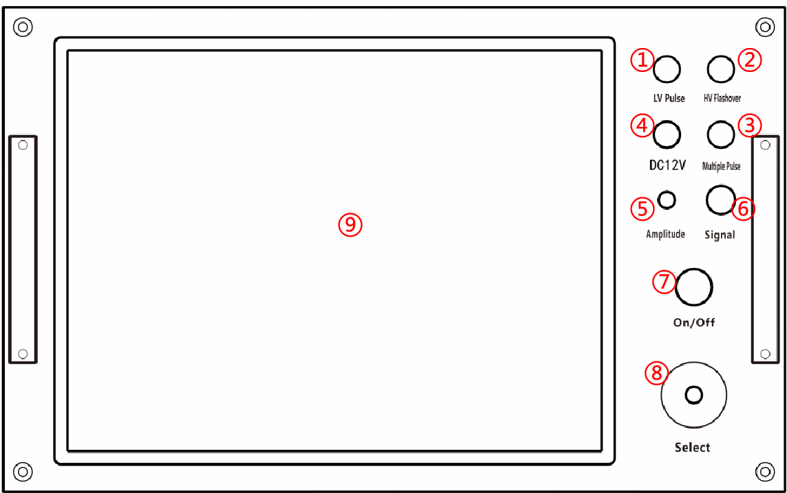
Tester panel schematic
1. Pulse method indicator: green diode, green light on after power on, the working state in the pulse method test state.
2. Flashover method indicator: red diode, when the working state is in the high pressure flash sampling state, the red light.
3. Multiple times method indicator: red diode, when the working state is in the state of multiple pulse sampling, the red light is on.
4. Charging socket: Please use the dedicated DC12V3A power adapter.
5. Output amplitude: Used to adjust the input and output pulse amplitudes. When in use, adjust according to the waveform displayed on the screen. If the adjustment is too small, the pulse reflection is very small, or even cannot be sampled, as shown in the figure below (left). If the adjustment is too large, the reflected pulse is connected to the baseline without intersection, and the baseline may even become a slash, as shown in the figure below (right). Generally, before sampling, the input amplitude knob is rotated about 1/3, and then adjusted according to the size of the sampled waveform and resampled.
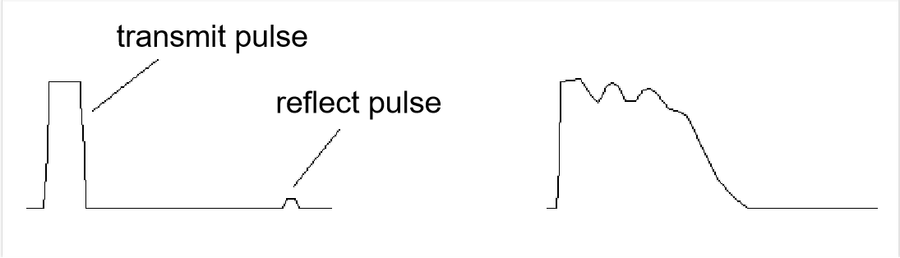

6. Output socket: The instrument uses a 9-hole aviation socket, which is the communication control port between the tester host and the trolley.
7. Power switch: This switch is the DC power switch of the instrument. Press and release it, the low-voltage pulse indicator light will light up, and the instrument will automatically turn on and display the test interface after 7 seconds. After the test is completed, just turn off the switch.
8. Selection key: Rotate to complete the operation of various functions of the entire system. Press this key to confirm.
9. Distance measuring host LCD display: Do not press hard or place heavy objects.

(b) Cart panel schematic

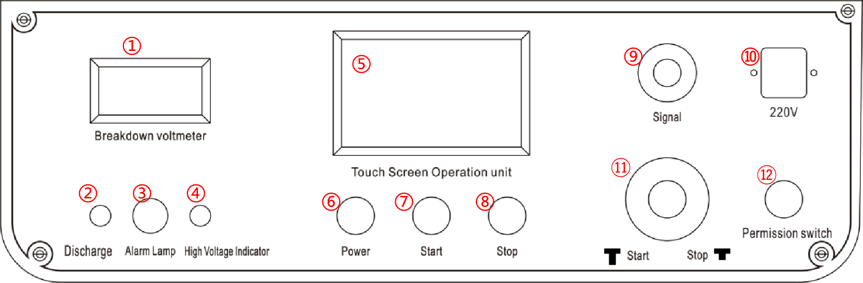
Cart panel schematic
1. High-voltage meter: Displays the working value of the power supply voltage, and determines whether the fault point is broken down and discharged by lowering and raising the voltage through the pointer.
2. Discharge indicator light: After emergency stop or shutdown and power failure, the automatic discharge indication is displayed. As the high voltage inside the instrument is gradually discharged, this light gradually changes from bright to dark;
3. Alarm light: An alarm device that integrates sound and light. The main function is to indicate the automatic discharge state of the high-frequency high-voltage power supply.
After turning on the power switch, the alarm device starts to alarm. After setting the voltage and starting, press the start button (emergency stop/start button, rotate clockwise and automatically pop up, indicating start), the discharge mechanism will automatically release the alarm when it is pulled open. In this case, the instrument automatically performs boost discharge according to the set voltage.
After the test is completed and the emergency stop button is pressed, the alarm device starts to work, and when the power is turned off, the alarm device will turn off.
4. High-voltage indicator light: When you click the "Start" button on the "Boost Operation" interface, the instrument will automatically boost the voltage and the indicator light will be on;
5. Display screen: 640*480 resolution 5.6-inch touch LCD screen, which can set voltage, single pulse, continuous pulse and other operations, and display the discharge time and working time of the instrument;
6. Power switch: It is the power switch of the high-voltage part. After the authority key is turned to "1", the white light of the power switch is on, and when the power switch is pressed, the white light goes out and the green light of the start key is on
7. Start key: It is a high-voltage start key. When the ⑥ power switch is pressed, the ⑥ white light goes out and the green light of the start key is on, prompting the operator to proceed to the next step and start boosting.
8. Stop key: It is a high-voltage stop key. When the ⑦ start switch is pressed, the ⑦ green light goes out and the red light of the stop key is on, prompting the operator to proceed to the next step and stop reducing the voltage.
9. Signal: Use a 9-hole aviation socket, which is the communication control port between the tester host and the trolley.
10.220V: 220V/50Hz standard three-core socket, built-in 10A fuse.
11. Start/Emergency Stop Knob: Press it to indicate emergency stop; rotate it clockwise and it will pop up automatically to indicate start; in any case, you can press this key to stop it from working and automatically release the high voltage;
12. Authority Key: Insert the special key, the "0" position means the main power of the high voltage part is turned off, and the "1" position means the main power of the high voltage part is turned on.
(C) Introduction of wiring schematic at the rear panel of the cart
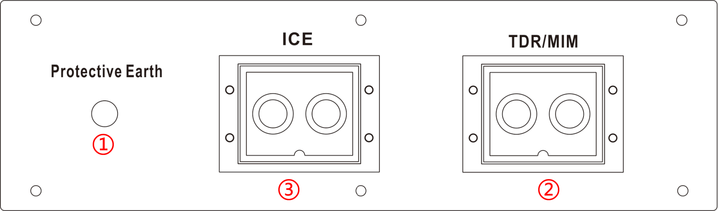

1. System ground: For the chassis grounding set for safety protection, a dedicated grounding wire must be used and connected to a reliable grounding electrode.

(If the on-site grounding conditions allow, keep it as far away from the cable grounding as possible, and the grounding resistance should be less than 6 ohms).

2. Multiple pulses: This is a dedicated port that outputs single or continuous multiple pulses and is used for multiple pulse method test wiring;

3. High-voltage flash: This is a common port that outputs single high-voltage pulses or continuous high-voltage pulses, flash current method testing, and fault fixed-point wiring

Section II: Testing steps for power cable faults

Analyze the nature of the cable fault, understand the type of faulty cable

Use the low-voltage pulse method of the cable tester to test the cable length and calibrate the cable's radio wave transmission speed.

Select the appropriate test method and use the cable tester to perform a rough measurement of the cable fault

IV. Use a path meter to detect the direction of the buried cable

V. Use a fixed-point meter to accurately locate the fault point

Section III. Introduction to Cable Testing System Software

I. Cable test system host
After pressing the power switch, the low-voltage pulse indicator lights up, and after 7 seconds the instrument automatically turns on and displays the test interface. After the test is finished, turn off the switch directly.
It is recommended that the unit not be powered off or switched on and off frequently while in use.
If the host computer shows undervoltage, please insert the host computer special 12.6V3A lithium battery charger, you can continue to work. The charger indicator is red under charging status and green when the battery is full.

II. Introduction to the test system control interface
The system automatically enters the test interface after powering on, and the test interface is shown in Figure 1 below
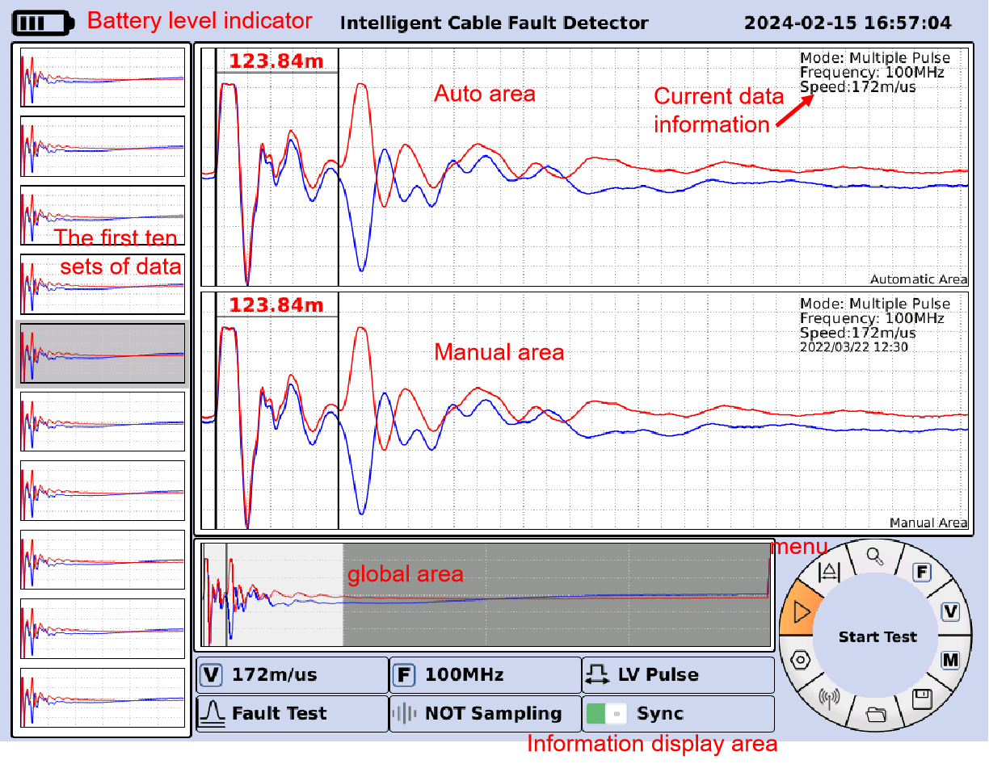
Figure 1 Software testing interface
(i) Waveform display area
The waveform display area is mainly divided into automatic area, manual area, global area, and the first ten groups of waveform display area.
The automatic area displays the latest data waveform for each acquisition, and the current fault distance is displayed in the waveform area for low-voltage pulse or multiple-pulse test methods.
The manual area and the global area display the same waveform.
The manual zone displays any set of data waveforms selected by the user and can be fault jammed with a knob.
The global area displays the full view of any set of data waveforms selected by the user. The waveforms in the non-shaded part of the global area correspond to the waveforms in the manual area, and you can select the Adjust View function with the knob to compress or extend the waveforms.
On the left side of the interface are the first ten waveform display areas. As sampling continues, the ten waveform display areas are updated from bottom up, i.e., for newly collected data waveforms are displayed in the bottom area, and the first data waveform is overwritten. When the user clicks on a waveform, the background of the waveform display area is brighter.
Clicking on the small arrows to the right of the manual and auto zones expands the manual and auto zones respectively, providing users with a good visual effect for waveform jamming and view adjustments.

(ii) Other displays
The upper left corner of the interface displays the current remaining battery power of the instrument, and when the battery is undervoltage, it will display the insufficient power, which is convenient for users to charge the instrument in time.
The current time is displayed in the upper right corner of the interface, if the time is not accurate after the power on, users can use the knob to open the "Other Settings" to set the time by themselves.

(iii) Display of test information
The lower side of the interface is the test information display area, which mainly includes the current wave speed, cursor position (the distance of the manual snap fault), the current test method (the default is the low-voltage pulse test method), the X-axis distance (the actual distance corresponding to the full-wavelength of the manual zone (and also the non-shaded portion of the waveform in the global zone)), and 50 ohms (the output impedance).

(iv) Rotating menu

The lower right corner of the interface is the menu selection area. Clockwise: Start sampling, adjust the card position line, adjust the view area, set the fault measurement, set the speed measurement, view historical data, save data files, open data files, print reports, and other settings.

The "Start Sampling" function is selected by default when the system is powered on. Users can select specific functions by turning the knob, and the text description of the corresponding function is displayed in red font on the left side of the rotating menu. The default acquisition mode at power-on is single mode, and users can set it to continuous mode. The text description is displayed on the left side of the rotating menu.

For specific descriptions of each function, please refer to the instrument operation manual.

III. Operational steps
Power on: Press the power switch and then release it. After 7 seconds, the instrument will automatically power on and display the test interface. The power on function can be realized.
- Fault detection
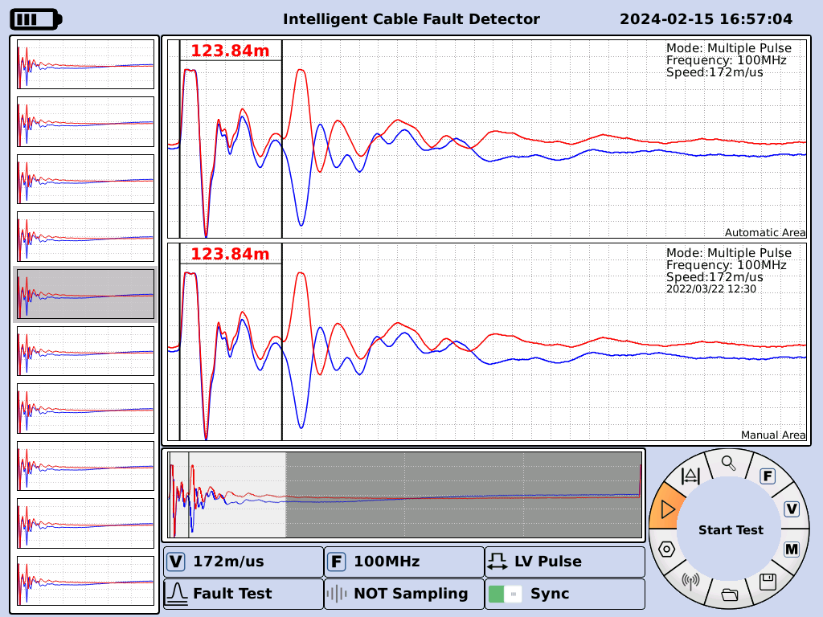
Figure 2 Fault Detection Setting Level 1 Menu
As shown in Figure 2, rotate the knob to make the focus switch to , and the left display will show "Fault Measurement Setting". Press the knob to enter the fault test setting interface, as shown in Figure 3. Rotate the knob to switch the focus between test mode, fault cable length L range selection, media selection, delay factor, OK and cancel. Select test mode: rotate the knob so that the focus is placed on a certain test mode (low-voltage pulse or high-voltage flash or multiple pulses), and press the knob button, you can select the test mode.
Select sampling frequency: rotate the knob so that the focus is placed on a certain length range (there are eight length ranges, from top to bottom corresponding to the sampling rate of 400 MHz, 200 MHz, 100 MHz, 50 MHz, 25 MHz, 12.5 MHz, 6.25 MHz, 3.125 MHz, respectively), and press the knob button to select the sampling frequency.
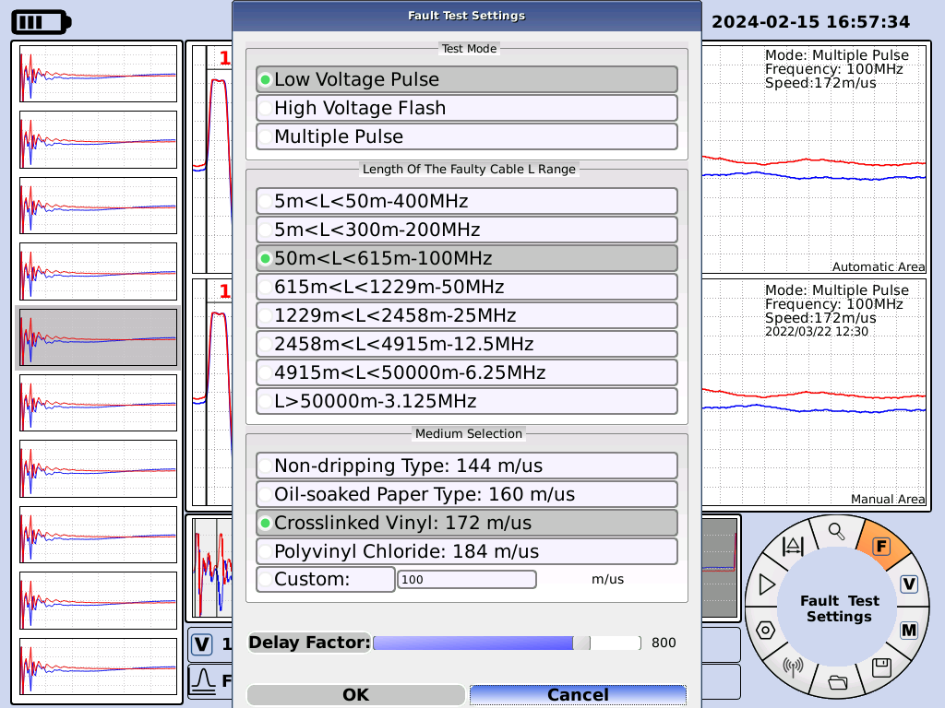
Fig. 3 Fault Detection Setting Interface Fig. 4 First Level Menu after Successful Setting of Parameters
Select wave speed: rotate the knob to focus on a media option, and press the knob button to select the media, when you need to use self-selected media, select the "self-selected media" label, press the knob button, use the pop-up numeric keypad to enter the wave speed. When the above way to select the test mode, sampling frequency, test speed, rotate the knob to switch the focus to the "OK" button and press the knob button, you can set the parameters successfully. At this time, the first level of the menu interface as shown in Figure 4, the focus should be on . Sampling mode selection has single and continuous two ways, through the rotary knob can realize single or continuous sampling selection, press the knob button to start sampling.

- Measure the speed
As shown in Fig. 5, rotate the knob to make the focus switch to , press the knob button to enter the speed test interface, as shown in Fig. 10. Pressing the knob button, the focus switches between cable length, fault cable length L range selection, confirmation and cancel.
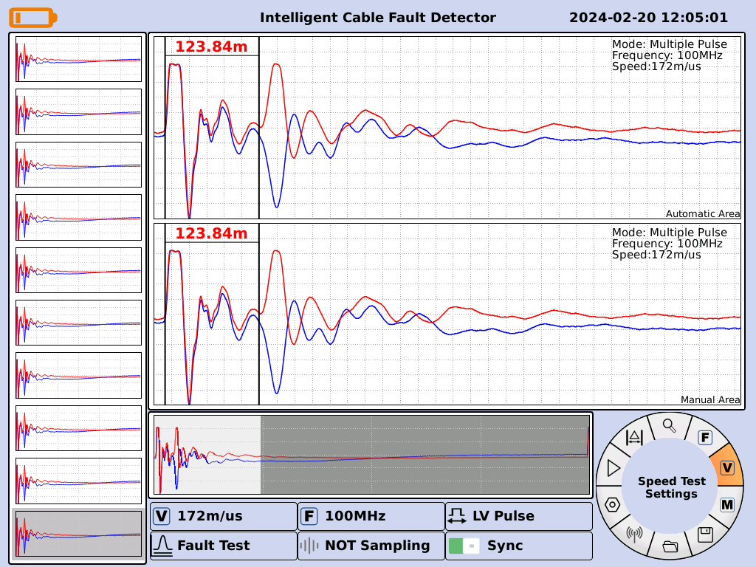
Fig. 5 Speed measurement setting first level menu
Setting the cable length: rotate the knob so that the focus is on "Cable Length", press the knob button, and use the pop-up numeric keypad to input the wave speed.
Select sampling frequency: rotate the knob so that the focus is placed on a certain cable length range (there are eight length ranges, from top to bottom corresponding to the sampling rate of 400 MHz, 200 MHz, 100 MHz, 50 MHz, 25 MHz, 12.5 MHz, 6.25 MHz, 3.125 MHz) and press the knob button to select the sampling frequency.
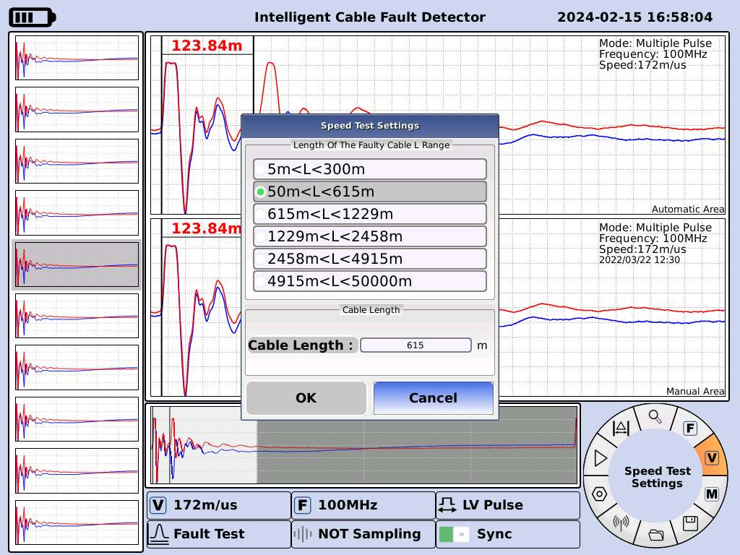
Fig. 6 Speed test setting interface
After selecting the cable length and sampling frequency as described above, rotate the knob to switch the focus to the "OK" button and press the knob to set the parameters successfully.
After setting, rotate the knob to the point shown in Figure 3 for data acquisition.

3. Ranging card position :
As shown in Figure 7. Rotate the knob so that the focus switches to , press the knob button, rotate the knob to adjust the position of the red snap line, and press the switch button on the control panel to switch from the coarse measurement mode to the fine measurement mode. Press the selector button on the control panel to adjust the blue line. Press the knob to exit the "Line Adjustment" menu and return to the main menu.
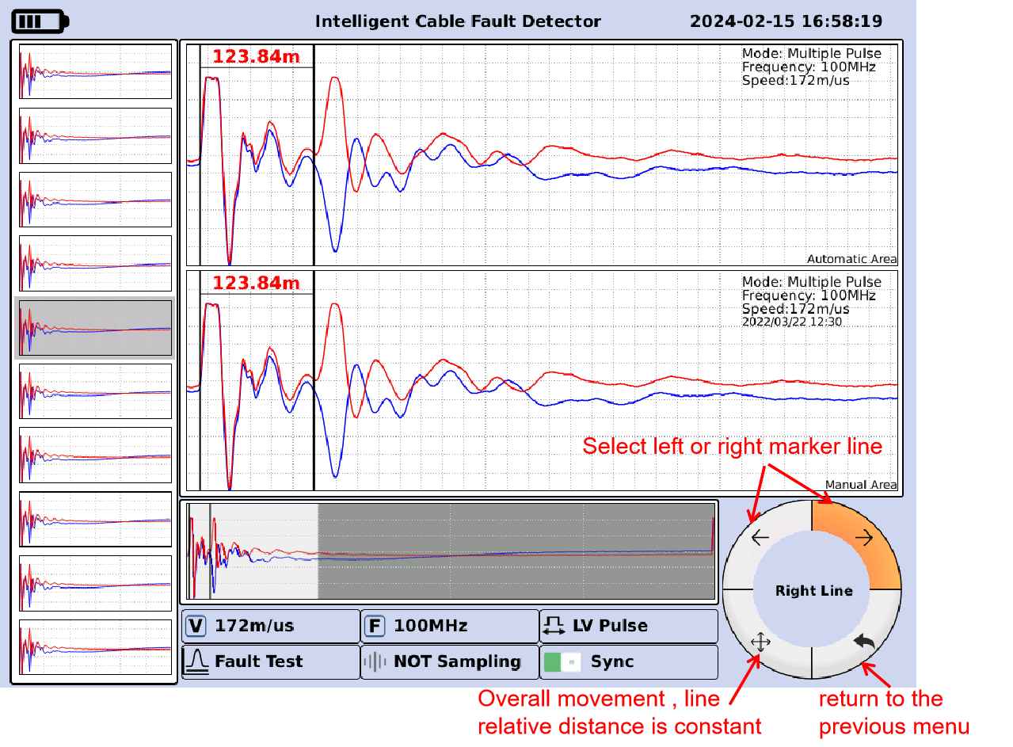
Figure 7 Snap line adjustment secondary menu
The main interface display area shows the current actual jam distance (fault distance) as shown in Figure 8:
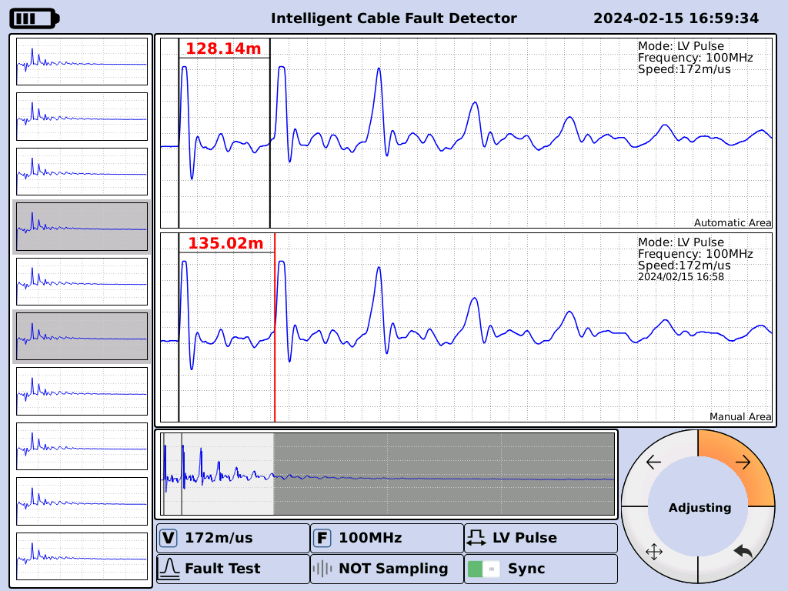
Fig. 8 Fault distance display interface

4. View Adjustment
As shown in Figure 9, rotate the knob to make the focus switch to , press the knob button to enter the view adjustment interface, and rotate the knob to make the waveform compressed or stretched, as shown in Figure 10.
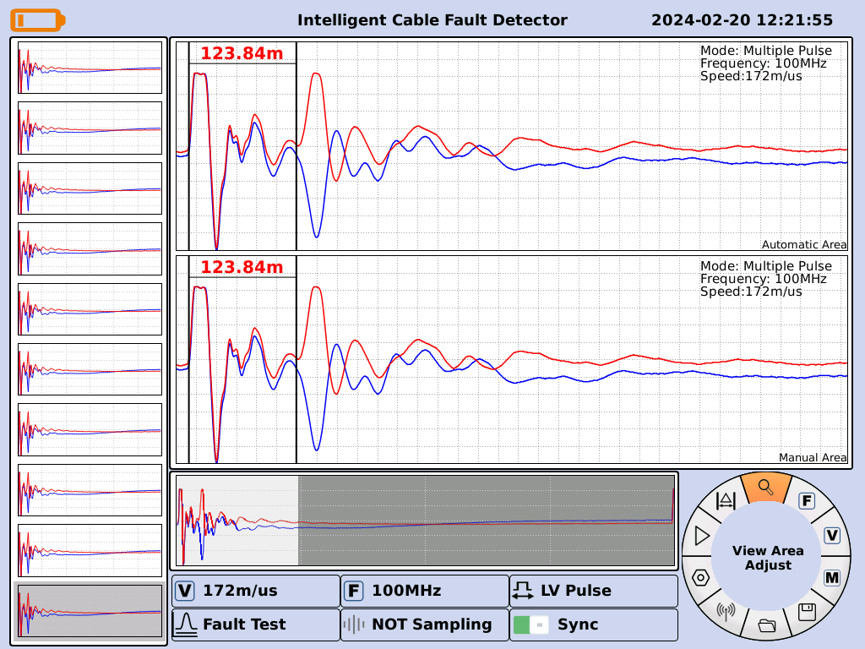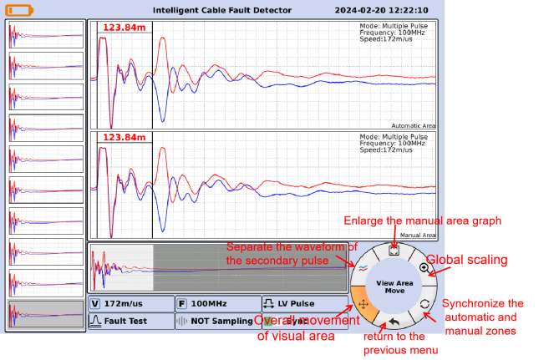
Figure 9 View Adjustment Level 1 Menu Figure 10 View Adjustment Screen

5. Open historical data
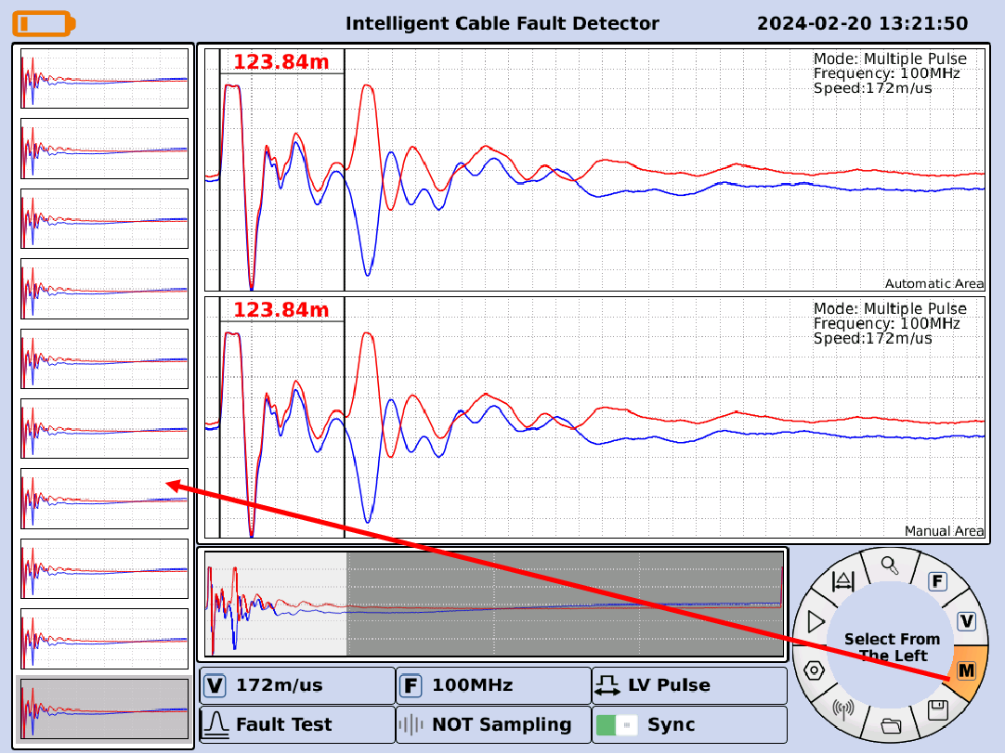
Figure 11 Historical Data Selection Screen
As shown in Figure 11. Rotate the knob to focus on a historical data, and press the knob button to select the historical data, and then use the knob button to switch the focus to the "OK" button, press the knob button, you can display the waveform of this data in the manual area.

6. Save data
According to the operation method of "Open Historical Data", select a certain group of data (e.g., select the 8th group of data), and then, as shown in Fig. 12, rotate the knob so that the focus is switched to , and press the knob button to save the group of data.
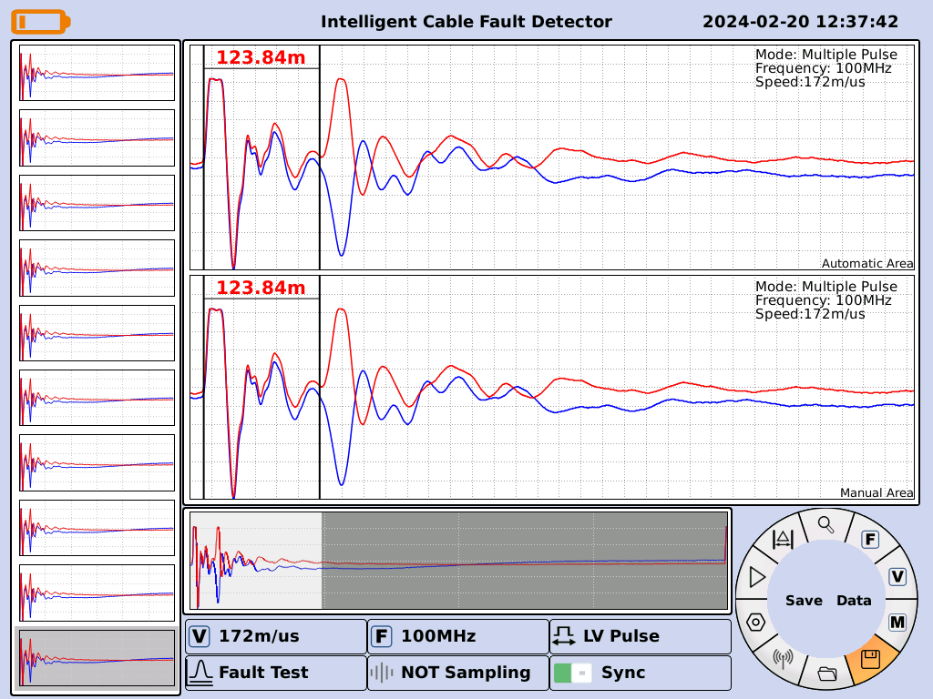
Figure 12 Save Data File Level 1 Menu

7. Open the data
As shown in Figure 13, rotate the knob to switch the focus to and press the knob button to enter the open data interface. As shown in Figure 14, rotate the knob to switch the focus and press the knob to open the data and exit the interface.
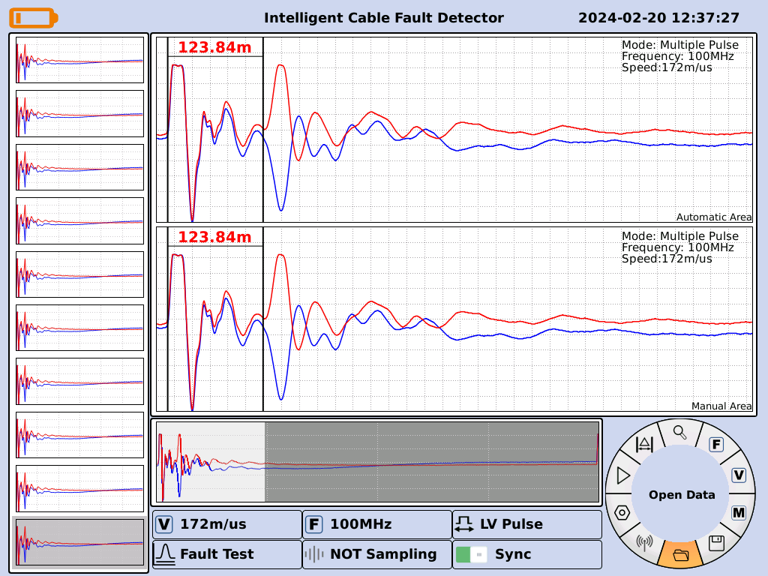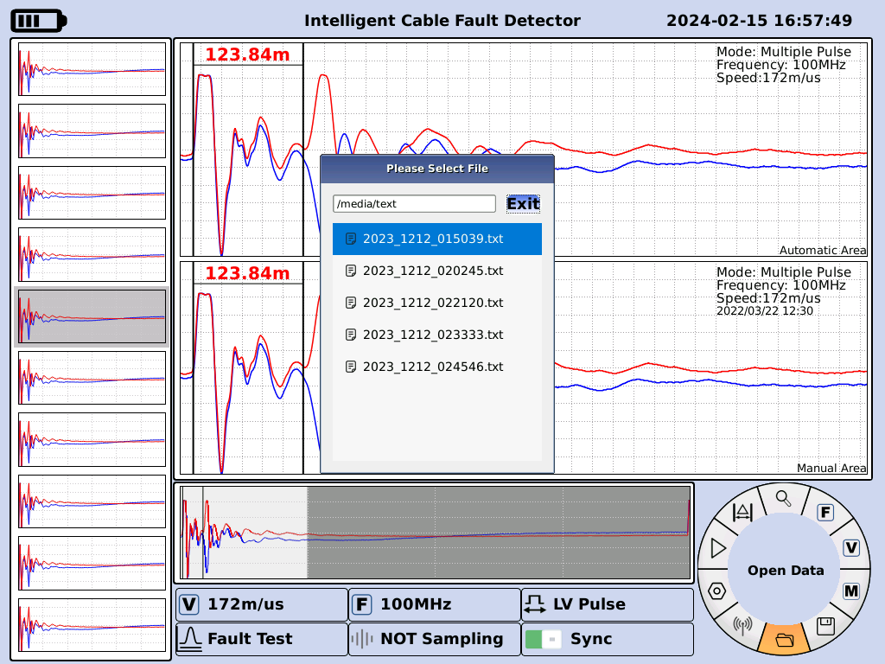
Figure 13 Open Data File Level 1 Menu Figure 14 Open Data Screen

8. Other settings
As shown in Figure 17, rotate the knob to make the focus switch to , press the knob button to enter the other settings interface, as shown in Figure 18, press the knob button to make the focus switch to the backlight, the size can be adjusted by rotating the knob.
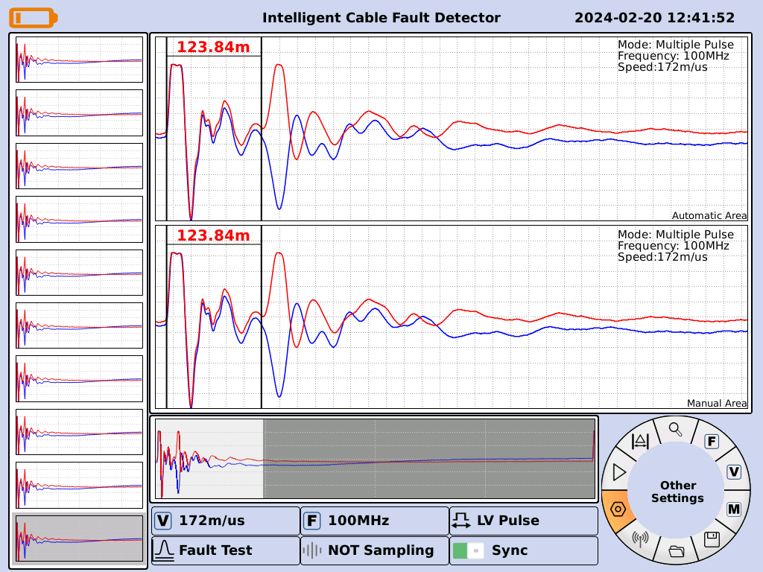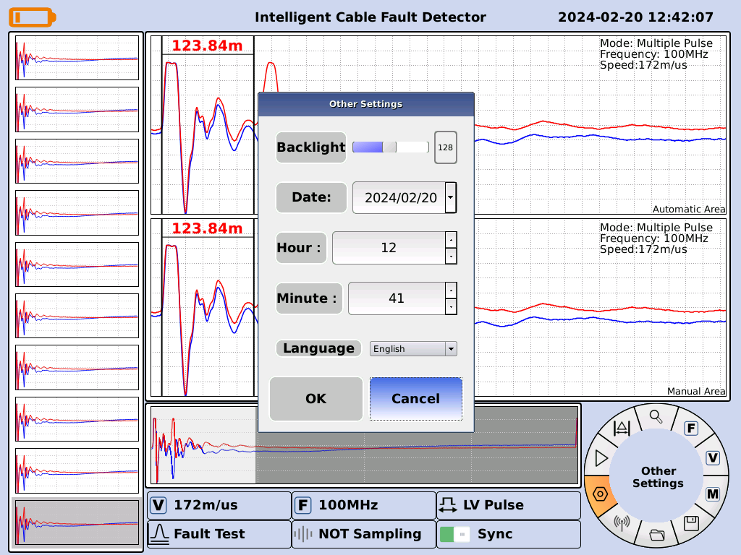
Figure 15 Other Settings Level 1 Menu Figure 16 Other Settings Screen

Date Adjustment: Cursor selects "Date", press the knob button, you can switch between "Year", "Month", "Day", select the position to be adjusted, press the rotary button and select it through the knob. Switch, select the position to be adjusted, press the rotary button and then select through the knob.
Time Adjustment: Press the knob button after the cursor selects "hour" and "minute", and adjust the size through the knob.
Language Adjustment: The cursor selects the language and you can switch between English, Chinese, Russian and Turkish. The following figure:
Figure 17 Other Settings Screen
When all settings are complete, focus on the "OK" button and press the knob to complete the settings.

9. Shutdown
Press the switch to power off directly.

Section IV. Introduction to cable test methods

I. Cable fault test principle
The main body of this instrument adopts the principle of Time Domain Reflection (TDR), which transmits a series of electric pulses to the cable under test and receives the reflected pulses in the cable due to the change of impedance, and then, according to the propagation speed of the electric wave in the cable and the time represented by the characteristic inflection points of the two reflected waves, it can be measured that the distance from the fault point to the test end is:
S=VT/2
Where: S represents the distance from the point of failure to the test terminal
V stands for the speed of propagation of the wave in the cable
T stands for the time it takes for a radio wave to travel back and forth through the cable
In this way, with V known and T already measured, the distance of the fault point from the test end can be calculated S. All this can be done automatically by the computer with only a little human intervention, and the fault can be tested quickly and accurately.
This test system fault test has three basic ways: low voltage pulse method, multiple pulse method, and impulse flash current method.

II. Low-voltage pulse test method
Low-voltage pulse is used to test the speed of wave propagation in the cable, the full length of the cable, low-resistance faults (fault phase resistance value is lower than 1K) and open-circuit faults and short-circuit faults, the host can complete the task. At the same time, the test data gives the next step in the application of multiple pulse method to test the cable high resistance faults provide a reference basis.
1.The basic principle of pulse test
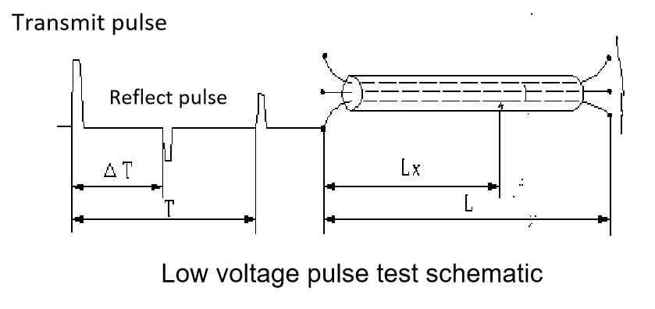
Measurement of cable faults, the cable can be regarded as a uniformly distributed transmission line, according to the transmission line theory, the pulse voltage added to one end of the cable, the pulse according to a certain speed (determined by the dielectric constant of the cable medium and the permeability coefficient) along the line to the far end of the transmission, when the pulse encounters a fault point (or impedance inhomogeneity) will produce a reflection, and the flash meter to record the transmission time between the sent pulse and the reflection of the pulse T, the Can be known according to the transmission speed V to calculate the distance from the fault point S, S = V - T / 2, as shown in the figure above: measuring the full length of the terminal can be used to reflect the pulse: L = V - T / 2
Again the full length is known and the transmission speed can be measured: V = 2S/T
During testing, a low-voltage pulse is added to the faulty phase of the cable, which propagates along the cable until the impedance mismatch is reached, such as intermediate joints, T-connectors, short-circuit points, disconnection points, and termination heads, etc., where the reflection of the wave is induced, and the reflected pulse is picked up by the tester when it returns to the test end of the cable. The tester can display this change process in time.
According to the test waveform of the cable we can judge the nature of the fault, when the transmitting pulse is in phase with the reflected pulse, it indicates a broken circuit fault or an open terminal head. When the transmitting pulse is in-phase with the reflected pulse, it is a short-circuit grounding or low-resistance fault.
Where the cable fault point insulation resistance drops to the cable's characteristic impedance, or even the cable resistance of zero faults are known as low-resistance faults or short-circuit faults (Note: This concept is defined from the perspective of using the low-voltage pulse reflection method, taking into account the impact of different impedances on the polarity of the reflected pulse changes).
Where the cable insulation resistance is infinite or although with the normal cable insulation resistance value is the same, but the voltage can not be fed to the user end of the fault are known as open-circuit (disconnection) fault.
The fault phase (or phase under test) and ground of the cable are connected to the input line of the test system (the other end of the input line is connected to the test system's aviation socket).

2. Rough measurement of faults Distance
Important tips for choosing a low voltage pulse test method:
First of all, in the upper half of the rear panel of the machine Figure 3, the first two 7-core communication control line will be connected to the tester host and the trolley, and then equipped with 25m high-voltage cable red and black plug into the low-voltage pulse +, - port, while accessing the 1-protection grounding. Then start the power supply of the instrument, open the cable test software, select the low-voltage pulse test method, according to the relevant parameters to complete the setup interface, and then check the setup and wiring is correct before starting the test.
As shown in Figure 1, rotate the knob to make the focus switch to , and the left display shows "Fault Measurement Setting". Press the knob to enter the fault test setting interface, as shown in Figure 2. Rotate the knob to switch the focus between test mode, fault cable length L range selection, media selection, delay factor, OK and cancel.
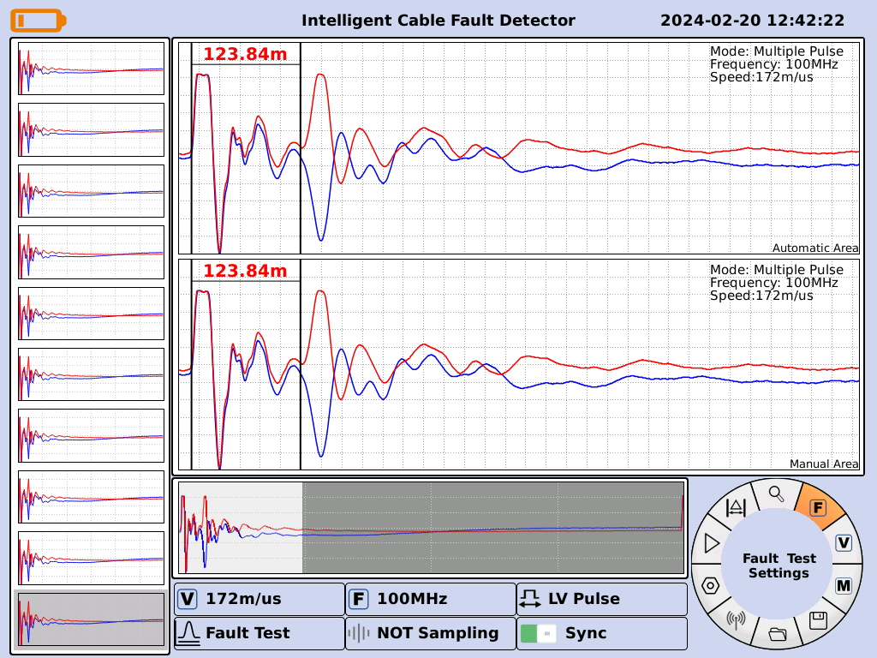
Figure 1 Measurement Fault Setting Level 1 Menu
Figure 2 Measurement Fault Setting Screen
Select Test Mode: Rotate the knob so that the focus is on a particular test mode (low voltage pulse or high voltage flash or secondary pulse) and press the knob button to select that test mode.
Select sampling frequency: rotate the knob so that the focus is placed on a certain length range (there are eight length ranges, from top to bottom corresponding to the sampling rate of 400 MHz, 200 MHz, 100 MHz, 50 MHz, 25 MHz, 12.5 MHz, 6.25 MHz, 3.125 MHz, respectively), and press the knob button to select the sampling frequency.
Select wave speed: rotate the knob to focus on a media option, and press the knob button to select the media, when you need to use a self-selected media, select the "self-selected media" label, press the knob button, use the pop-up numeric keypad to enter the wave speed.
After selecting the test mode, sampling frequency and test speed as described above, rotate the knob to switch the focus to the "OK" button and press the knob to set the parameters successfully. At this time, the first level menu interface as shown in Figure 3, the focus should be on . Sampling mode selection has single and continuous two ways, by rotating the knob can realize single or continuous sampling switch, press the knob button to start sampling.
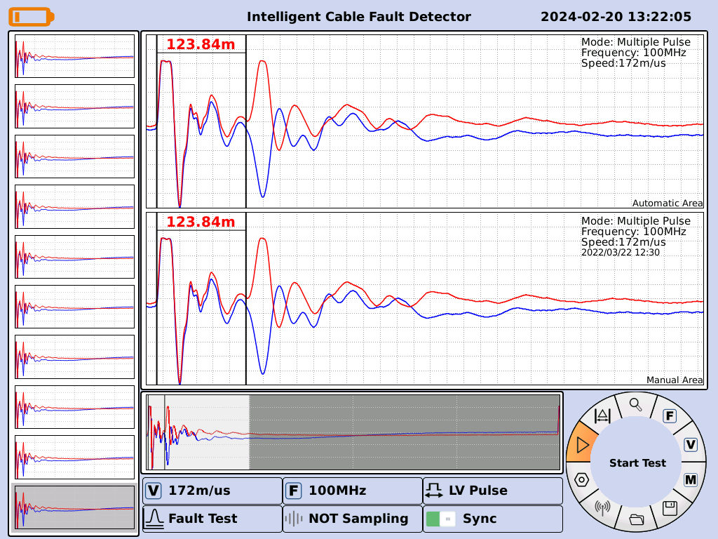
Fig. 3 First level menu after successful parameterization
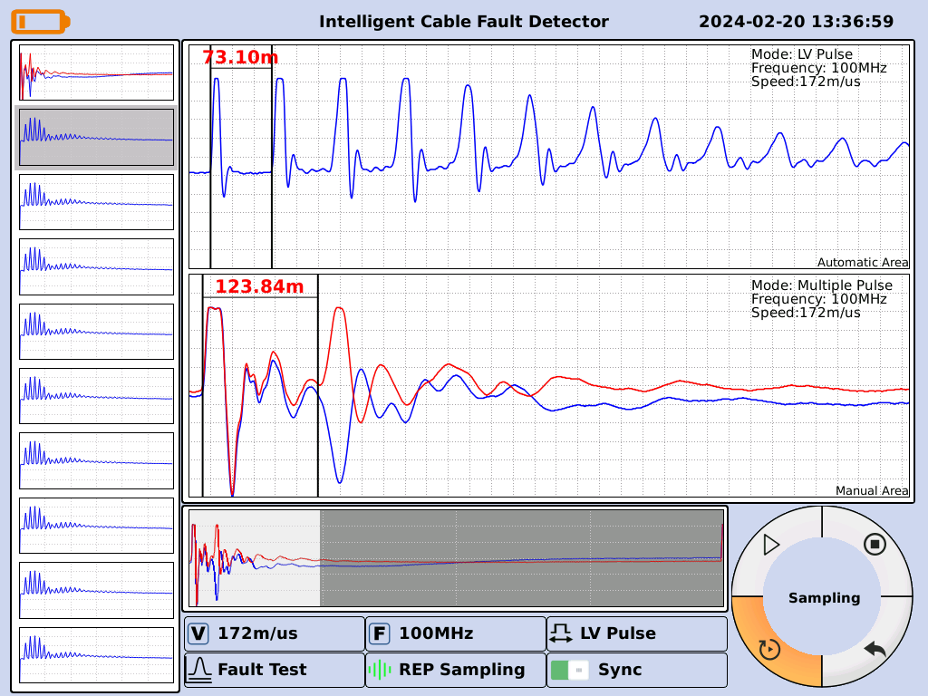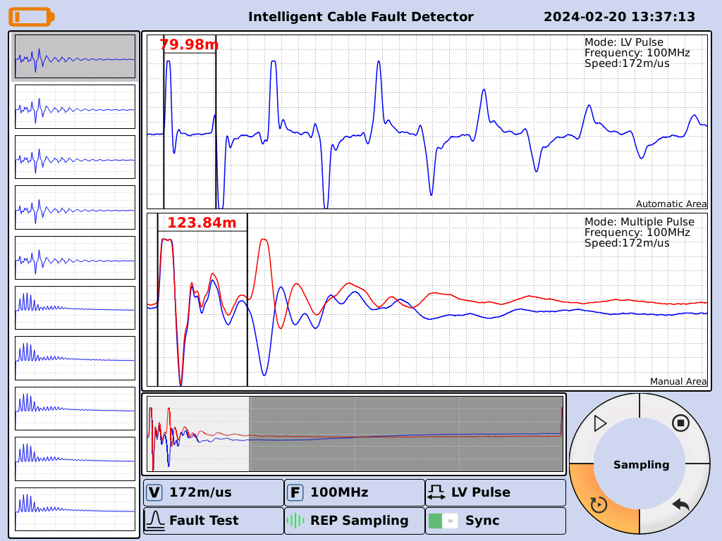
Open fault or open full-length waveform measured by low-voltage pulse method Short-circuit fault or low-resistance fault waveform measured by low-voltage pulse method

3. Rough measurement of propagation speed
As shown in Fig. 4, rotate the knob to make the focus switch to , press the knob button to enter the speed test interface, as shown in Fig. 5. Pressing the knob button, the focus switches between cable length, fault cable length L range selection, confirmation and cancel.
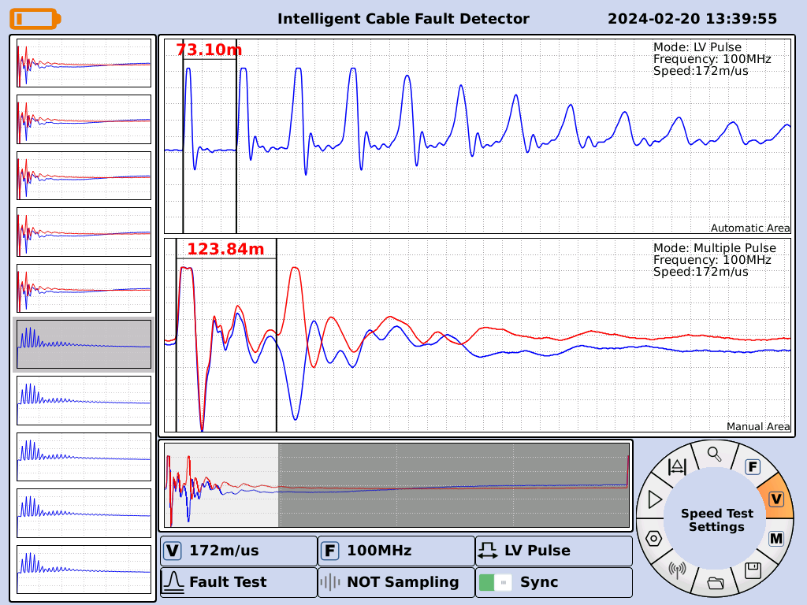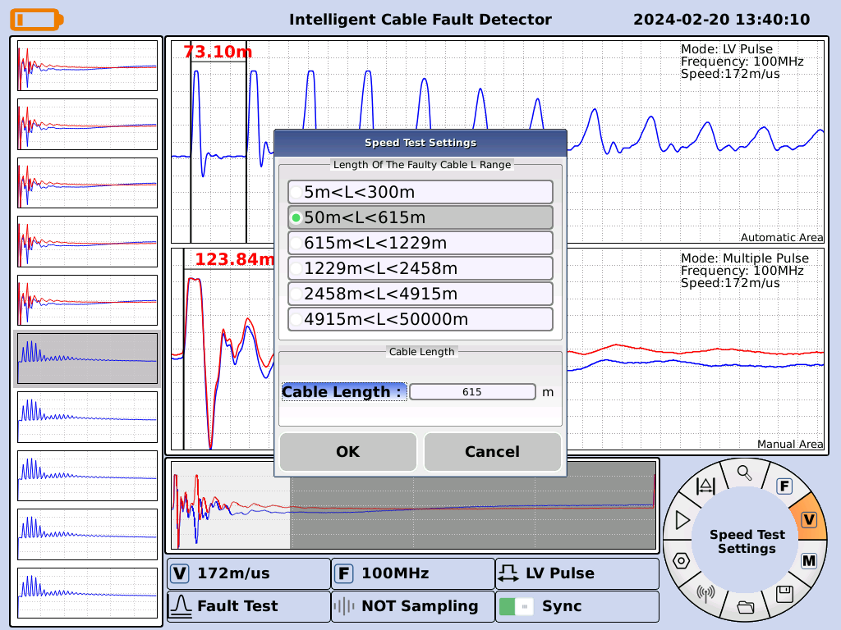
Fig. 4 Speed measurement setup first level menu Fig.

4. Speed test setup interface
To set the cable length: rotate the knob to set the focus on "Cable Length", press the knob button, and use the pop-up numeric keypad to input the cable length.
Select sampling frequency: rotate the knob so that the focus is placed on a certain cable length range (there are eight length ranges, from top to bottom corresponding to the sampling rate of 400 MHz, 200 MHz, 100 MHz, 50 MHz, 25 MHz, 12.5 MHz, 6.25 MHz, 3.125 MHz) and press the knob button to select the sampling frequency.
After selecting the cable length and sampling frequency as described above, rotate the knob to switch the focus to the "OK" button and press the knob to set the parameters successfully.
After setting, rotate the knob to the point shown in Figure 3 for data acquisition.
Measurement of faults when the working state menu select "low-voltage pulse", and then select the appropriate cable length range corresponding to the sampling frequency, and then press the test distance to select the cable under test corresponding to the pulse speed, and then press the "Sampling" button, the top of the screen will display the open-circuit waveform (as shown) or short-circuit waveform (as shown), multiple-pulse cable fault tester has an automatic card function, the screen automatically waveform area waveform will automatically card Waveform (Figure) or short-circuit waveform (Figure), multiple pulse cable fault tester has an automatic card function, the screen automatically waveform area waveforms will automatically be card position, or from the left to test multiple pulse waveforms to select one, in the "manual waveform area" that is, the display of the fault waveforms, with the vernier card position, the test results are immediately displayed.
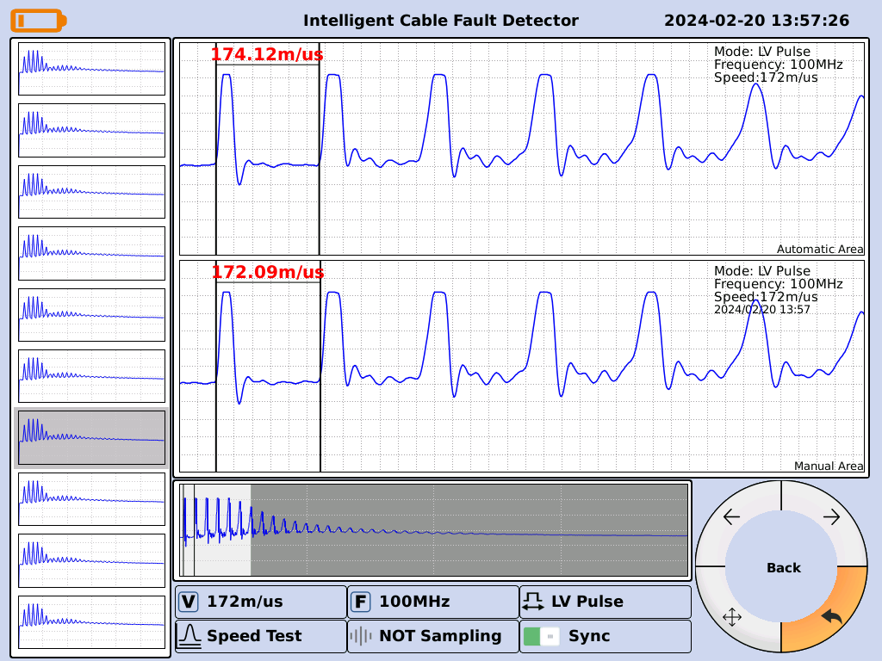
The interface after the speed test is completed

III. Multiple Pulse Test method
If the resistance value of the power cable fault is greater than the characteristic impedance value of the cable, we are regarded as high-resistance faults (high-resistance leakage faults and high-resistance flashover faults) can be tested by the multiple pulse method first. Preparation before testing: At the site, first of all, the test method, setup, wiring corresponds to a good connection. Cable fault phase, system grounding wire, cable grounding wire must be accurately connected.
The block diagram of the working principle of the cable fault test system with multiple pulse method is shown below
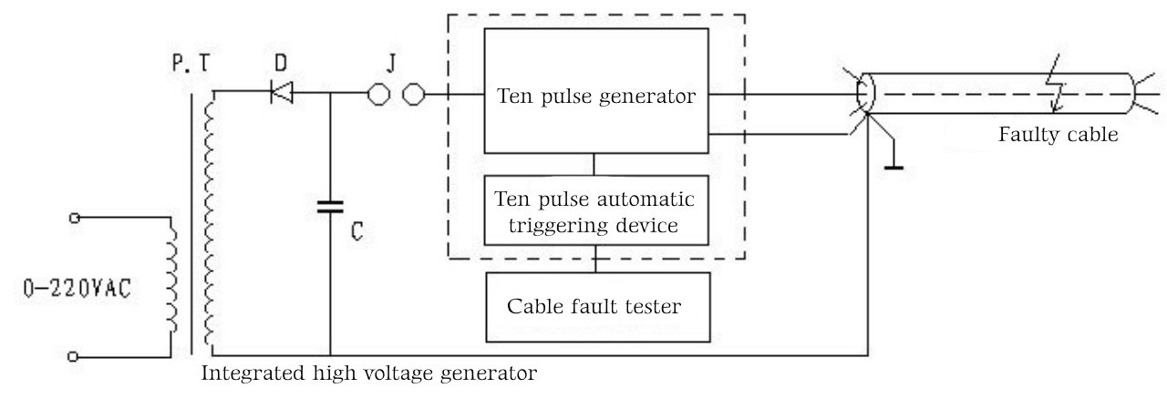
Cable Fault Test System Block Diagram

As a cable fault test system adopting multiple pulse method, this set of instruments includes "integrated high voltage generator" which can produce single impact high voltage, "multiple pulse generator", "multiple pulse automatic trigger device This instrument includes "integrated high voltage generator", "multiple pulse generator", "multiple pulse automatic triggering device" and cable fault tester with waveform analysis and processing software. For convenience, the "multiple pulse automatic triggering device" and the cable fault tester are combined together, collectively referred to as the "multiple pulse method cable fault tester".
Important tips for choosing a multiple pulse test method:
First of all, the two 9-core communication control line will be connected to the tester host and trolley, and then equipped with 25m high-voltage cable red and black plug into the lower part of the rear panel of the machine many times the pulse port, and at the same time, reliably connected to a good system ground, carefully check the boot after no error. Start the instrument power supply, open the multiple pulse cable test software, select the multiple pulse test method, in accordance with the relevant parameters to complete the setup interface, the instrument will automatically be multiple internal pulse generator access and signal port switching.
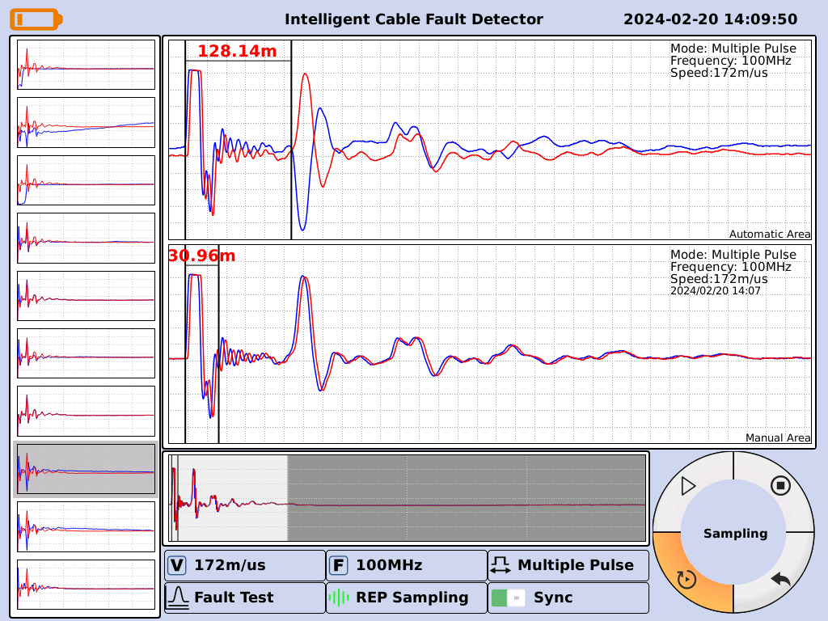
The fault point is not broken down by the impact high voltage or the "delay coefficient" is adjusted to a large waveform
Rotate the mouse to choose to start the test, you can start the cart high-frequency high-voltage unit to start the flash discharge. The impact of high voltage to 15KV or so, the first test. If the impact of high-voltage measured after a number of pulse waveform group by the selected broadening of the waveform shown in the figure above, that is, the upper and lower two waveforms are exactly the same. Waveform blue, red completely overlap, and the polarity of the two echo pulse and the polarity of the transmitter pulse is the same, the cursor positioning display is the full length of the cable, indicating that the point of failure is not impact high-voltage breakdown or "delay factor" is adjusted too large. Must re-press the "sampling" key (after the instrument into the automatic sampling state, do not have to press the "sampling" key), and increase the impact voltage. While raising the surge voltage, sample and monitor the screen. At the same time, adjust the size of the "delay factor" until you see the screen above the automatic waveform area waveforms appear with the opposite polarity of the transmitter pulse return pulse until. As shown in the figure below. At this point, the test waveform displayed on the screen should be the final sampling results, but also into the selection of a number of pulse groups in the "manual waveform area" artificial analysis. If the selected waveform group is not satisfied enough, you can click on the left side of the screen multiple pulse waveforms of another waveform to analyze the card position and automatic waveforms and the fault distance comparison, close to or the same as the end of the rough test.
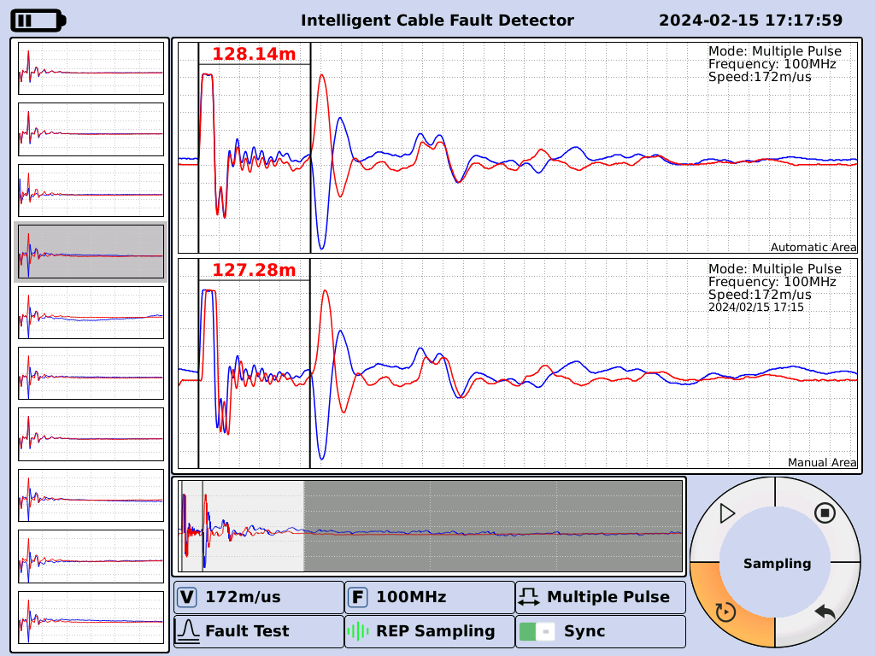
Test waveforms of the multiple pulse method
Once the standard waveform is captured, the high-frequency high-voltage unit can be stopped, and then the waveform distance can be read.
Mobile cursor reading fault distance: This software is fully automatic setup, divided into upper and lower two areas, the upper area will automatically from the left side of the waveform is an optimal and automatic card position; automatically show the fault distance. If you feel uneasy, you can do the following operations: rotate the mouse to adjust the card position line, press the switch button on the control panel can be switched from the coarse measurement mode to the fine measurement mode. Press the Select button on the control panel to select the blue line. Then rotate the mouse to adjust the position of the snap line until you move the two cursors to the inflection points of the starting waveform and the return waveform.
After completing the above operations, the information display column can show the distance from the fault point to the test end.
After the test is completed, if the operator believes that the test results have value to be retained, he can choose to save the data, and the operation method of saving the test results can be referred to in the operation steps of the data saving related to the content of the description.
Multiple pulse waveform test is completed, you must rotate the mouse to select the sampling method of low-pressure pulse or high-pressure flash, the instrument will be automatically switched to the internal multiple pulse generator separation, shutdown and then remove all the connecting wires.

IV. Flash Flow Test method
High resistance faults in power cables (high resistance faults: faults where the DC resistance at the fault point is greater than the characteristic impedance of that cable are high resistance faults) account for almost 90% or more of all fault rates. Although the multiple pulse method easily solves most of the high-resistance faults, but due to the problem of voltage drop caused by the multiple pulse generator and the situation of the discharge point of the extra-high resistance faults, the multiple pulse method is unable to help. This is where the flash current method comes into play, and the machine is equipped with both traditional test methods. Most of the cable high-resistance faults (high-resistance leakage faults and high-resistance flashover faults) can be tested using the flash method, but the waveform is complex, so that the user is not good at grasping the waveform of high-resistance faults, and often the error of rough testing is relatively large.
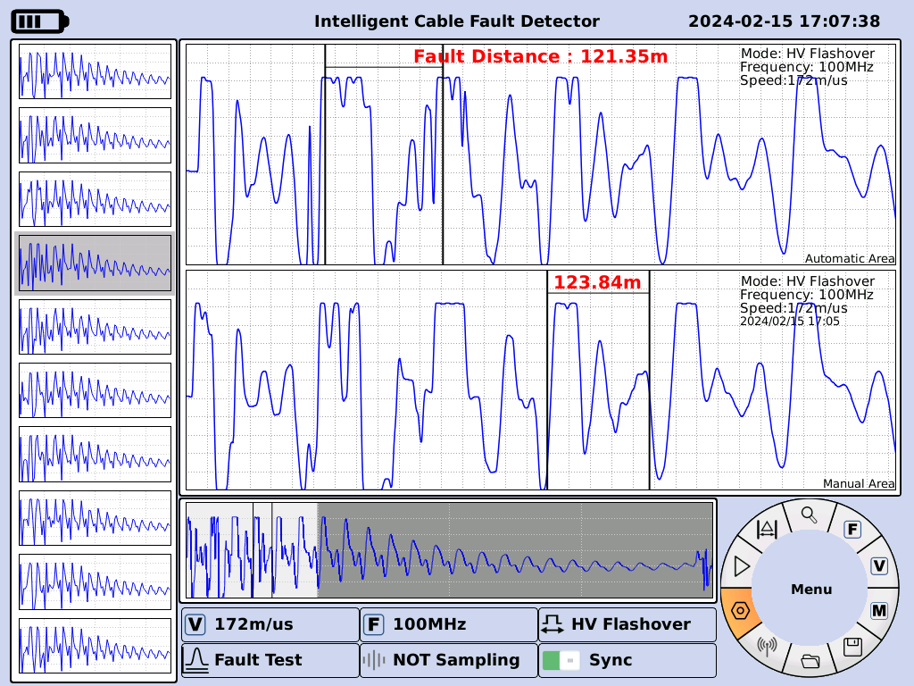
Flash test waveform
Important tips for choosing a high voltage flash test method:
First of all, in the lower part of the rear panel of the machine Figure 4 with a 25m high-voltage cable red plug access 5-flash pulse output (fault phase), the black plug reliable access to 4-high-voltage ground port, and then the ground line access 1-protection ground port, sampling box near the black plug next to the high-voltage line. Then start the power supply of the instrument, open the cable test software, select the flash current test method, according to the relevant parameters to complete the setup interface, carefully check the settings and wiring is correct and ready to start testing.
The current sampling method is generally used to test faults in the flash mode. Current sampling is recommended because of its simple wiring, high security and easy recognition of waveforms. Connected according to the wiring diagram, in accordance with the above description of the operation, the input amplitude knob rotated to about 1/3 (Note: please fine-tune), and then rotate the mouse to start the test and press, the instrument enters the waiting sampling state.
Input amplitude knob, and then energized on the fault cable voltage rise, the voltage rises to a certain value, the fault point flashover discharge occurs, the instrument records the waveform. According to the size of the waveform can be re-adjusted input amplitude, repeat sampling, until the relative standard waveform. Flash test waveforms are shown in the figure above.
Characteristics of waveform: The transmit pulse is positive, and the reflected pulse is also positive but with negative backlash at the leading edge. Due to the nature of the fault and other reasons, the size of the negative backlash is different, but much smaller than the amplitude of the positive pulse.
When setting the cursor, first press the "Select" key, the blue cursor line becomes thicker, then select the blue cursor line at the intersection of the rising edge of the positive impulse and the baseline, if you think that the cursor line is not in place, press the "fine-tuning" and then use the rotary mouse to adjust left and right until it is appropriate, then press the "Select" key, the red cursor line is selected at the intersection of the falling edge of the negative impulse and the baseline. "Select" key, the red cursor line is selected in the negative backlash along the falling edge and the intersection of the baseline, if you think that the cursor line is not in place, press the "fine-tuning" and then use the rotary mouse to adjust left and right until the appropriate place, the bottom of the screen information display area shows the distance of the fault that is the host rough test The distance of the fault is displayed in the information display area at the bottom of the screen.
If no negative pulse appears, set the end point cursor at the intersection of the rising edge of the reflected pulse and the baseline, and the fault display distance in the test result area at the bottom of the screen will therefore increase by about 10%. You only need to subtract about 10% from the displayed fault distance to accurately fix the point.
If you are not satisfied with this card for the starting point, the end point of the selected inflection point, you can re-card position. (This test method because the waveform is more complex, not set up automatic card position) such as in the case of difficult failure waveforms can be actively contacted with our company.
The change rule of the change pattern of the test waveform of the flashover method
The following figure is our according to the flashover test method waveform and draw the change rule chart, as long as carefully observe and analyze can see the change rule in them. Hope that the user must master the standard waveform and their change rule in different zones.
Cable beginning Cable middle Cable end

Section V. Instructions for use of high-frequency, high-voltage power supply units
Warnings
Welcome to use the HM-A50 trolley cable fault tester produced by our company. This product is an integrated automated and highly integrated comprehensive test equipment. Please do not operate this instrument before reading the instruction manual in detail to avoid danger.
Before powering on, please be sure to check whether all wiring is correct and good. The pulse output line should be suspended and keep a safe distance from the surroundings. The high-voltage ground and the protective ground must be independently and reliably grounded. Check whether the grounding resistance value meets the standard. Is the emergency stop/start button in the emergency stop state (pressed state). In addition, is the discharge rod connected for standby.
Before removing the high-voltage connection after the test, please turn off the power first, and use the discharge rod to fully discharge the cable. After no less than 5 seconds, remove the high-voltage line, power line, etc. in turn, and finally remove the protective grounding line.
We will continue to improve and perfect it as always. There may be some discrepancies between this manual and the instrument. Please forgive me! If you have valuable comments, please feel free to contact us.
Note: High voltage is dangerous, please make sure that the high voltage grounding and protective grounding are independently and reliably grounded before testing!

Section V. High Voltage Power Supply Unit Instructions

I. Operation panel
See section 1 for panel descriptions

II. Touch display
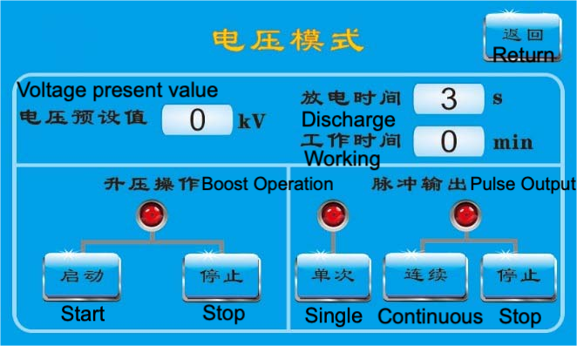
Voltage setting: Click on "Voltage preset value" to set the voltage. The setting range is 6-32kV;
Boost control: After setting the preset voltage, in the "Boost operation" interface;
Click the "Start" button, the machine will automatically boost the voltage, the boost indicator turns green; (before starting, the emergency stop/start switch must be rotated clockwise and automatically popped up, at this time, the emergency stop/start switch is in the start state, before boosting the voltage)
When you click the "Stop" button, the machine will stop boosting and the boost indicator will turn red.
Pulse Output: After the boost is set on the screen, the "Pulse Output" screen will be displayed;
Click the "Single" button, the instrument will output a single pulse and stop automatically;
Click the "Continuous" button, the instrument works in continuous high voltage pulse mode, the continuous pulse indicator turns green;
Click the "Stop" button, the instrument stops continuous high-voltage pulse output, and the continuous pulse indicator turns red.
Discharge time: Discharge time is automatically displayed according to the set voltage.
Working time: real-time display of the instrument's continuous pulse working time.

III. Introduction to use
After all the wires of the device are connected, please self-test the device first.
The self-test process is as follows:
After the power on, the alarm lamp starts to work, under the voltage mode, after setting the voltage 6KV and start, then rotate the start/emergency stop button, at this time, the alarm lamp goes out. When the voltmeter pointer starts to rise, select continuous under the pulse output menu, and after 4S, you will hear the sound of action inside, and at the same time, the voltmeter pointer will fall back. After a few discharge cycles, then press the start/emergency stop button, there is action sound inside the device, at the same time, the discharge indicator on the panel is always on and the alarm light is working. When the discharge indicator light is off, the automatic discharge of the equipment has been completed.
After completing these operations, it can be proved that all functions of the equipment are normal and the test operation can be carried out.
After the self-test is completed, there is no need to stop, you can directly set the desired voltage (it is generally recommended to step up the voltage sequentially from low to high), and operate according to the normal process.
A. Pulse output mode
This mode is used for multiple pulse method test, current impulse flash method test, fault location and other work, can output a single high-voltage pulse or continuous high-voltage pulse, continuous pulse period of 4s ~ 9s.
This section describes the operation process in detail in the way of fault fixing, and other references are made to the corresponding wiring schematic diagrams.
1 Complete wiring procedure:
a, pulse output wiring: high-voltage cable plug in the panel "high-voltage flash" jack, red clip end to connect the fault cable core, black clip end to connect the test site system ground. (Usually phase - armor (ground) fault, should be connected to the black clamp on the outer armor of the cable; phase - phase fault, the black clamp to one of the fault phase, and then reliably connected to the system ground.)
b. System ground: a dedicated 4-meter ground wire, one end of which is inserted into the "system ground" terminal, and the other end of which is clamped to the grounding braze on site. The location of the grounding brazier must be far away from the "high-voltage line black clamp ground".
(Special note: In the distribution room, if it is not possible to insert the grounding braze, the black clamp of the high-voltage wire is connected to the system ground, and the "system ground" is connected to the yellow and green two-color ground row of the enclosure wall of the distribution room. Confirm on site that the system ground and the yellow-green two-color grounding row are independent of each other). (The site confirms that the system ground and the yellow-green two-color ground row are independent).
c, the rest of the cable core wiring: in addition to the high-voltage line added to the faulty phase core, the rest of the cable core and armored shorted to the system ground.
d. Discharge rod wiring: Discharge rod with 3 meters of single-ended clamp line, clamp to the system ground.
Check:
Check in turn whether the switch is in the "off" state, whether the emergency stop button is pressed, whether the wiring is correct. If the check is normal, turn on the working power 220V.
Operation:
Open the switch, touch the screen light, discharge time display 3s, click on the screen "voltage preset value", set the voltage, and then click on the "boost" button in the "boost operation" interface. Clockwise rotation of the "emergency stop" button to start, when the voltage reaches the expected voltage, in the "pulse output" interface click on the "single" button, and then the internal instrument issued by the agency action sound. The voltmeter voltage will swing from high to low to high. If this change occurs, it means that the fault point has been discharged, you can directly click on the "continuous" button, indicating continuous output of high-voltage pulse; if there is no such change, it means that the voltage is low, you can continue to raise the voltage, and then operate and observe again until the fault point is discharged.
Downtime:
After the fault point is determined, click "Stop" button in "Boost Operation" interface, click "Stop" button in "Pulse Output" interface, and then press "Emergency Stop" button, after about 5 seconds, the panel "Discharge Indicator" light turns from bright to dark, and the voltage meter shows that the voltage returns to about 0kV. "button, and then press the "emergency stop" button, about 5 seconds later, the panel "discharge indicator" light from bright to dark, the voltmeter shows that the voltage is back to 0kV or so, turn off the switch, with the discharge rod to discharge the residual power of the cable being measured. After waiting for about 5 seconds, remove the equipment power line, high-voltage output line, cable grounding line, and finally remove the protective grounding line and the discharge rod.

IV. Precautions

This instrument is an integrated, highly automated, high-voltage device. If you encounter special cable faults [such as dead grounding (the multimeter test resistance is close to zero), high resistance faults (resistance greater than 200 megohms)], because of the built-in system integration, it is not suitable to use this device for testing. Please choose to use other high-voltage sources (test transformers) for testing or contact the manufacturer.

When the machine is shut down and automatically discharges, wait for about 5 seconds, and the discharge indicator light will turn from bright to dark. In the event of abnormal conditions such as sudden power failure, the host will automatically start the backup power supply to discharge. It is recommended to use the discharge rod to release the residual power of the capacitor at the cable end again.

During use, if the voltmeter pointer displays a certain voltage setting value, the meter head does not fall back for more than several discharge cycles, and the ignition action sound inside the device cannot be heard, please directly press the emergency stop button and turn off the power. Wait a while and restart the machine for testing. If there is no action sound inside the device after restarting several times, please contact the manufacturer.

Section VI HM-C10 Intelligent Fixed-point Meter Introduction

I. Overview of the Fixed Point Instrument
Because of the extreme complexity of the power cable laying environment, cable fault testing has been a very critical step in the precise location, even with accurate rough distance, but due to the influence of the external environment, we are also difficult to quickly and accurately locate. Intelligent fixed-point instrument is an ultra-quiet, visualization, noise reduction, including path indication of the precise fixed-point instrument, and high-voltage impact generator used in conjunction with the use of impact discharge in the cable fault point generated by the time difference between the magnetic field signal and the sound signal to accurately locate the exact position of the cable fault point, while using the background of the intelligent noise reduction and sound tracking of the new technology, which can be achieved by continuous optimization, the perfect sound effect, through the earphone listening Discharge sound, comes with precise pointing at the same time indicating the path function, to ensure rapid positioning.

(i) Technical characteristics
- Superior discharge sound quality, quieter background, optional monitor headset for fast and reliable fault location;
- Magnetic field signals can be selectively recorded for higher spotting accuracy, and trigger thresholds for sound and magnetic field channels are set fully automatically;
- Manual/automatic ultra-quiet technology is available;
- BNR Intelligent Background Noise Reduction Technology;
- Turns the shock discharge volume limit on and off;
- Black arrows are used in the receiver to automatically indicate the direction of travel for precise pointing;
- A yellow marking line is used in the receiver to indicate the relative left and right positions of the center axis of the faulty cable to ensure that the fixed point is always directly above the cable;
- The magnitude of the time difference between the two times before and after the impact discharge is utilized to determine the precise location of the fault point;
- Special self-falling ground-penetrating sensors with sensing connectors for soft pavement, hardened pavement, and lawn;
- Reliable imported connectors are selected to ensure the purity of sound, and the humanized design of the height-adjustable probe handle is very suitable.

(ii) Standard configuration
- One receiver main unit with shoulder strap;
- One sensor (ground-penetrating microphone);
- One height-adjustable handle, height range 450 - 750 mm;
- One headset with audio grade sound quality;
- One signal cable, connecting the receiver main unit to the sensor, is 1.20 m long;
- One hard ground probe, 18 mm long;
- One grass probe, 75 mm long;
- One charger;
- One Chinese manual.

(iii) Technical parameters
sports event | parameter value
Impact discharge sound amplification factor | >90dB, shock discharge volume limit 84dB(A) can be turned on or off
Sensor dynamic range  - sound channel  - magnetic channel | >104dB  >110dB
Sensor operating frequency | 100Hz--1500Hz
Filter Settings  - unfiltered  - low-pass filtering  - bandpass filtering  - high pass filtering | 100Hz--1500Hz  100Hz---400Hz  150Hz--600Hz  200Hz--1500Hz
power supply  - alkaline battery  - li-ion battery | >10 hours.  rechargeability
LCD Display | TFT super bright true color screen, 320x240

(iv) Connection and control of the receiver main unit
The following figure shows how to connect the main unit of the spotter receiver with the control buttons:
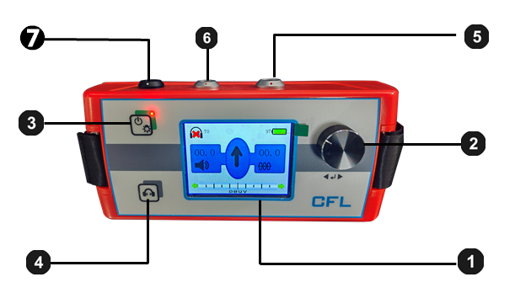
component | Functional Description
❶ | LCD Display
❷ | One-touch Adjustment Keys
❸ | Receiver main unit on/off (after 3 seconds of long press) Backlight on/off (brief press)
❹ | Mute on/off
❺ | Connecting socket to the sensor
❻ | Connects to socket for headphones
❼ | Charger Connector

II. On-site installation and operation of the fixed-point instrument

(i) On-site operations

(1) Preparation of fixed-point instrument sensors
- Connect the sensor to a suitable probe or probes
- Two different types of probe or probes can be connected to the Sensors, with an 18mm long hard ground probe and a 75mm long grass probe included in the standard configuration. These probes can be threaded to suit a wide range of ground cover conditions.
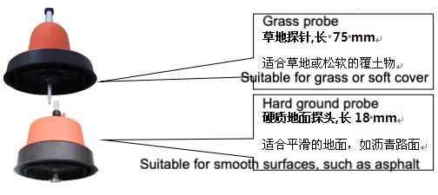
- Connecting the sensor to the handle
- The figure below shows the method of connecting the adjustable handle to the sensor:
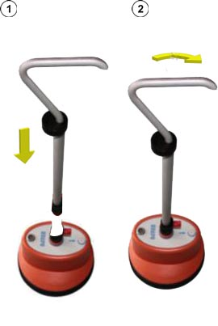
- Adjusting the height of the handle
- The diagram below shows how to adjust the height of the handle:
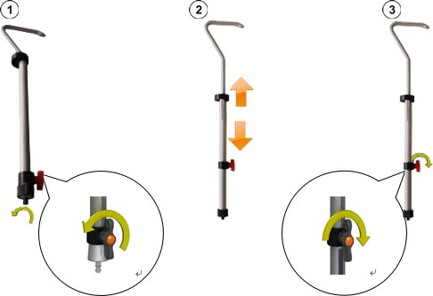

(2) Connect the sensor and headset to the main unit of the receiver.
- The diagram below connects the headset to the black socket of the receiver main unit . Note the white markings on the alignment plug and socket. The plug is plug-and-play; do not rotate it!
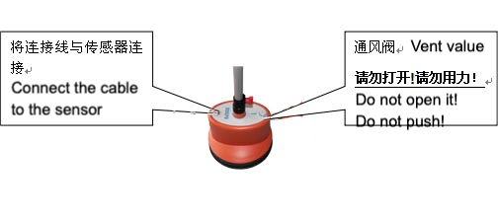

(3) Turning on the receiver main unit
- The main unit can be switched on or off by pressing the receiver's main unit's ON/OFF button . After a few seconds, the receiver main unit is ready for use and this is where the measurement screen will be displayed.

(4) Battery level self-test
- When you turn on the power, please look at the upper right corner of the display first to check the remaining power of the lithium-ion rechargeable battery. If you find that the percentage of battery power is close to 25%, please charge the battery first and start using it after the power is more than 50%.

(5) Backlight Selection
- The backlight function of the spotter is automatically activated after powering on the unit. The Fixed Point Meter is designed with a TFT ultra-bright LCD display. When using the environment with full sunlight, please press the backlight button briefly to turn off the backlight. This will extend the continuous working time of the receiver main unit in the field. The backlight of the Spotter can be restored at any time by briefly pressing the backlight button again.

(6) Fixed-point instrument one-touch adapter knob
With the exception of individual functions, the main unit of the receiver is mainly adjusted by the one-touch keys. Please refer to the following figure for the use of the one-touch adjustment keys:
signal | Functions of the measurement interface | Functions of the menu screen
 | Open the menu screen | Open the currently selected menu unit
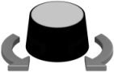 | Adjusting the volume (sound amplification) | Selection of menu units

(ii) Introduction to the interface

(1) Menu structure
- You can switch the spotter between the measurement and menu screens at any time, changing any setting in as little as 2 steps:
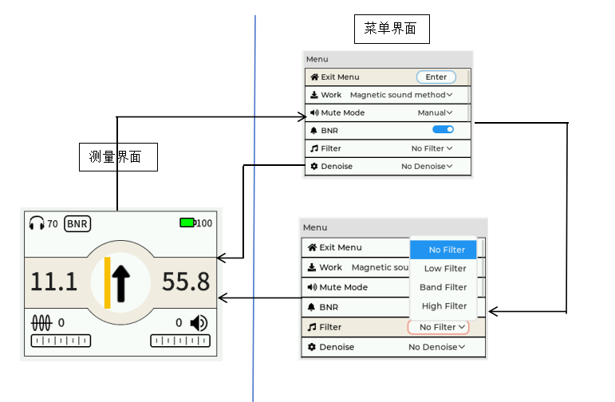

(2) Arrangement of menu screens
- Each menu screen consists of the following:
Return to the measurement screen
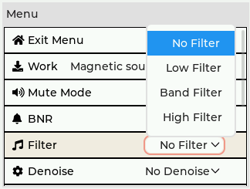
Currently selected menu
Functions not activated

current menu level

(3) Measurement interface display
- Not only does the pinpointing instrument provide an acoustic signal in the headset, but it also displays all the relevant information that may be useful through the measurement interface as you approach the point of failure during the precise pinpointing process.

Sound volume setting
Remaining Battery Power
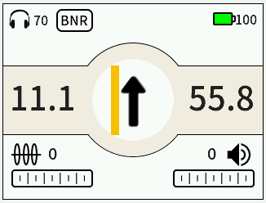
Time difference from the previous measurement point
Orientation of the point of failure

Strength of the received sound signal
Time difference of the current measurement point
Strength of the magnetic field signal

III. Getting started with fixed-point devices

(i) Precise spotting operating procedures

(1) Getting Started
Please connect the high-voltage integrated shock generator (high-voltage unit) to the faulty cable and start applying a suitable shock voltage to cause a flashover breakdown discharge at the fault point of the faulty cable. The suitable impulse voltage is the maximum permissible impulse voltage for the type of cable under test without causing damage to the cable under test. For more details on the use of high voltage shock generators (high voltage units), please read the operating instructions for the integrated high voltage power supply for this product.

(2) Positioning of the cable path under test
When the area you are pinpointing precisely is not large, usually what you need to do is to use the pinpointing instrument directly to find out the position of the center axis of the faulty cable and start pinpointing the fault point precisely. Please always point the arrow on the probe housing to the far end of the cable under test, move the probe left and right, observe the yellow marking line on the receiver display to the left and right, when the yellow marking line and the black arrow always overlap, it means that the probe is directly below the cable above the line of the center column, which will ensure the accuracy of the fixed point.

(3) Adjustment of settings for precise pointing
At any time when you press the single button of the stylus, the operator can switch the stylus from the measurement screen to the menu screen, where you can make the following most important measurement settings:
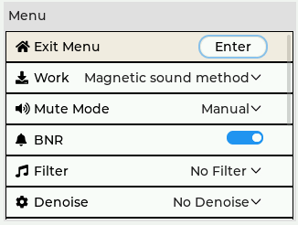
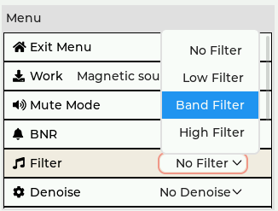
In this menu, you can make the following measurement settings:
menu unit | Functional Description
Activate/deactivate the fully automatic mute function | If prompted by this icon, the headset will automatically mute when the operator's hand is about to touch the handles of the spotter, a feature that effectively protects the operator from outside noise when moving the probe.
BNR | Enables/disables the background digital noise reduction (BNR) function.  Background Digital Noise Reduction BNR technology is used to make pinpointing easier when there is a lot of noise in the surrounding environment. Without BNR digital noise reduction, it is often not possible to recognize the target acoustic signal of a shock discharge in background noise, such as in the presence of a passing train, or to pinpoint a passing car. Similar acoustic disturbances make precise pinpointing of shock discharges very difficult.
filtering radio waves (i.e. pick out one frequency) | Filter Settings (see next page for description).

(4) Filter Settings for Precise Pointing
The sound of an impact discharge at the point of failure has a specific sound quality that changes on its own. The propagation of the discharge sound signal is strongly influenced by the surrounding overburden on the path of the sound wave. The speed of propagation of the sound wave, the distance from the sound source will affect the frequency of the sound wave received by the sensor of the fixed-point instrument. The faster the propagation speed and the smaller the distance from the source, the less attenuation of the high-frequency acoustic signal.
This means that in the actual field, where sound waves from hard overburden (e.g., under rocks and slabs) travel fast, we can expect to hear a high-pitched impact discharge sound in our headphones. Under these environmental conditions, use a high-pass filter to reduce the signal at lower frequencies, which will result in a more desirable and positive fix during precise pointing.
On the other hand, on sandy beaches or loose overburden, the high-frequency discharge sound signal is greatly attenuated, especially if the sensor is far away from the true point of failure. For such environmental conditions, we recommend that you use low-pass filtering to filter out the high-frequency signals. Also, the manner in which the ground-penetrating microphone comes into contact with the overburden medium through which the sound waves are traveling will affect the characteristics of the discharge you hear. This same principle of acoustic frequency behavior applies to the propagation of noise we don't want to hear. The noise you hear is also affected by the structure of the sound wave propagation path.
The actual operation depends on the working environment of the site, and is transferred to the menu screen by pressing the down-key under the measurement screen.
You can select one of the following filter settings.

Important Tip:
Please strictly follow the instructions for use!
This product is a high-voltage device. Some fault phenomena may cause discharge or open flames. Please note that it is strictly prohibited to use it in a high-gas or high-concentration flammable gas environment during testing. If you encounter this situation, please contact the manufacturer and take other methods to test. If a safety accident occurs as a result, it has nothing to do with the equipment manufacturer!

